**MINI-GNI ASSEMBLY DOCUMENT**

**April 2020**

**By**

**Chung Taing**

**Alison Nugent**

# Table of Contents

Table of Contents 2

Introduction: Parts and Wiring Diagram 3

Preparation 5

Soldering 6

Control Station Assembly 39

# Introduction: Parts and Wiring Diagram

This document contains the full details on the construction of the mini-GNI instrument and its control station. The Adafruit parts required are listed in Table 1. Note that the use of the BNO055 9-DOF Absolute Orientation sensor is optional, and this document does not detail its installation, though it is included in the wiring diagram. If the orientation sensor were to be installed, it would be wired as according to the wiring diagram, and it would be installed just above the barometer inside the mini-GNI.

|  |  |  |  |
| --- | --- | --- | --- |
| Part Name | Colloquial Name | Adafruit Part Number | Wiring Diagram Label |
| Adafruit Feather M0 with RFM95 LoRa Radio (comes with Male Headers) | Feather | 3178 | a |
| Adalogger FeatherWing with RTC + SD Add-on | Adalogger or FeatherWing | 2922 | b |
| MPL3115A2 - I2C Barometric Pressure/Altitude/Temperature Sensor | Barometer | 1893 | c |
| AM2302 (wired DHT22) Temperature-Humidity Sensor | Humidity Sensor | 393 | d |
| 9-DOF Absolute Orientation IMU Fusion Breakout - BNO055 | Orientation Sensor | 2472 | e |
| Micro Servo | Servo Motor | 169 | f |
| SPDT Slide Switch | Slide Switch | 805 | g |
| Lithium Ion Polymer Battery - 3.7V 150mAh | LiPo Battery | 1317 |  |
| CR1220 12mm Diameter 3V Lithium Coin Cell Battery | Coin Battery | 380 |  |
| 12-pin and 16-pin Female Header Set | Female Header | 2886 |  |
| Table 1: Adafruit parts list for building the mini-GNI. | | | |

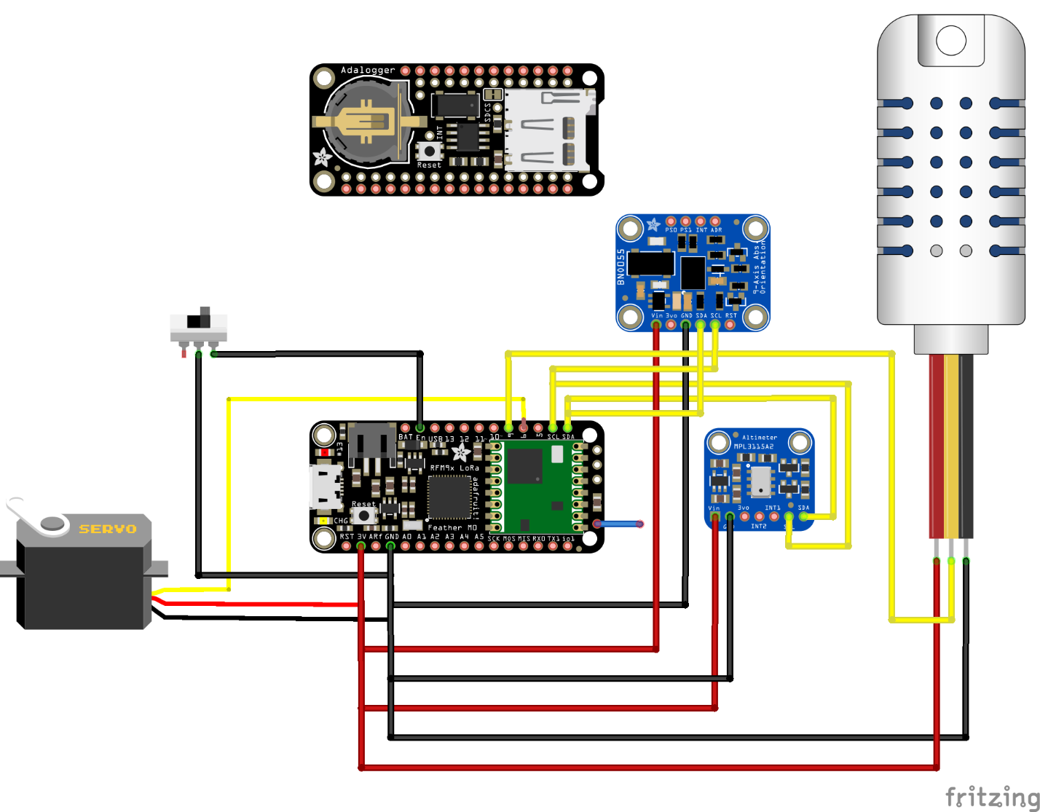

# Preparation

Cut wires (choose red for power and black/green for ground):

4 wires for Barometer:

2 wires (7 cm) for power and ground,

2 wires (3.5 cm);

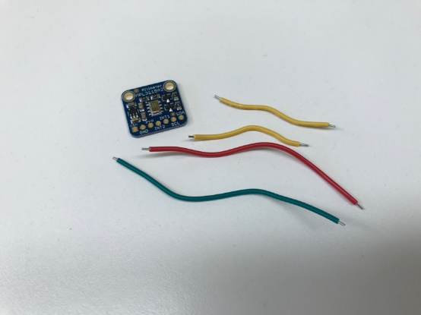

1 wire (8.3 cm) for antenna;

2 wires (7 cm) for power switch.

Cut wires that come with these items:

Servo Motor:

Cut red and brown wires down to 14 cm,

Cut yellow wire down to 12 cm;

Humidity Sensor:

Cut yellow wire down to 13 cm,

Cut red and black wires down to 11 cm.

Strip all loose ends for soldering except for one end of the antenna wire. Assemble the other items listed in Table 1.

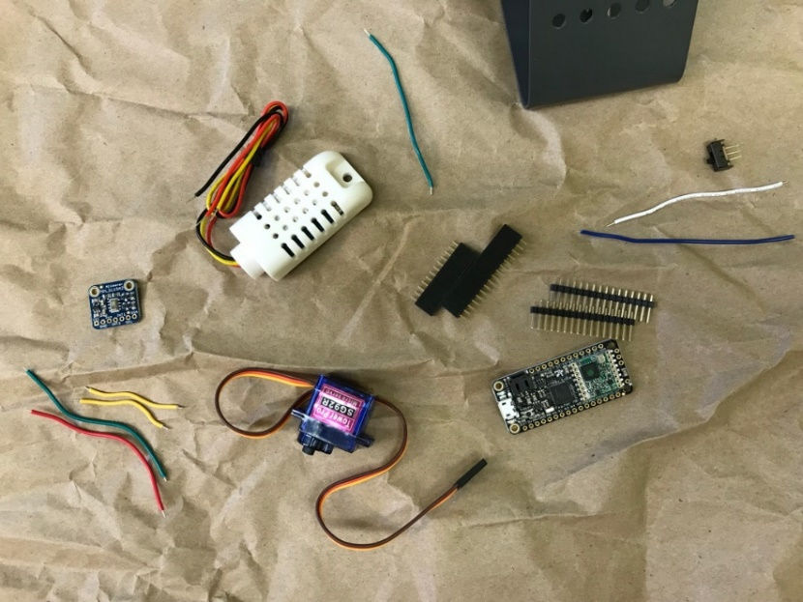

# Soldering

Follow all safety precautions for soldering. For example, use tweezers or clamps to hold wires to be soldered, use a non-flammable surface for your soldering setup, keep the cleaning sponge wet while soldering, never place the soldering iron down onto your workspace, and turn off the soldering iron when it is not in use.

Solder the antenna wire to the Feather M0. Insert the wire into the hole labeled “Ant” on the M0 from the USB side and solder from the side with the feather symbol. Set the Feather M0 aside until later. It appears as follows from the feather side.

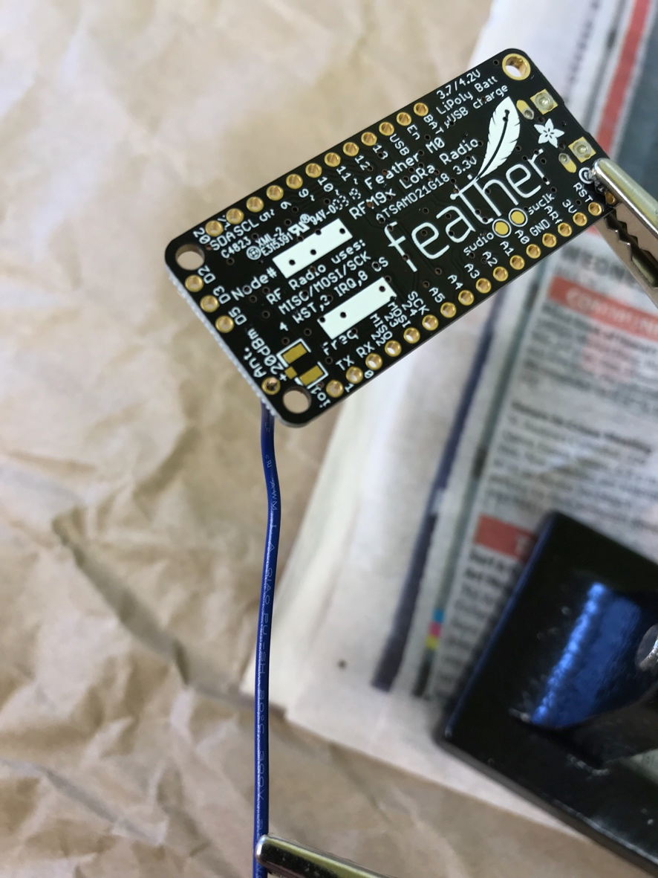

The Feather with the antenna wire appears as following from the USB side.

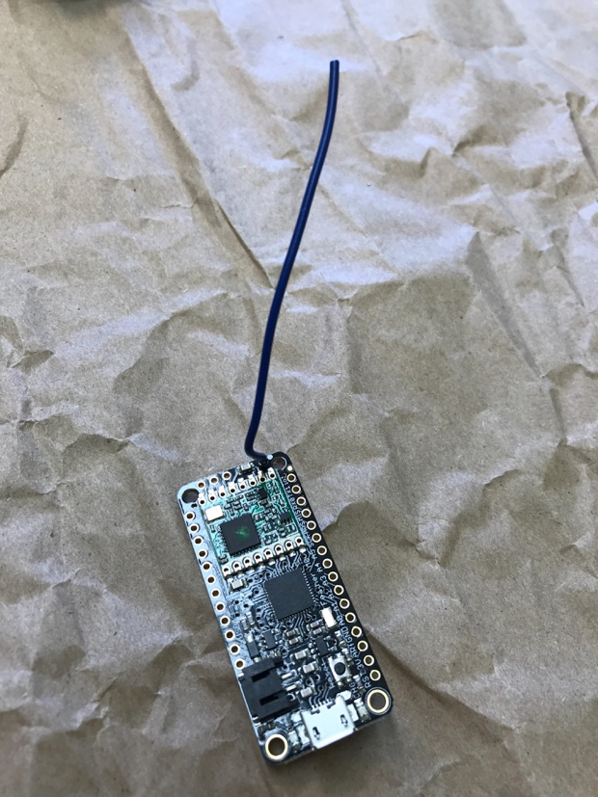

Solder one of the power switch wires to the Adalogger on an inner pin hole corresponding to En (next to Bat) on the Feather. Insert the wire from the side with the feather symbol and solder from side with the RTC and micro-SD add-ons, on one of the inner pin holes (the outer holes are later used for headers). It appears as follows on the add-ons side.

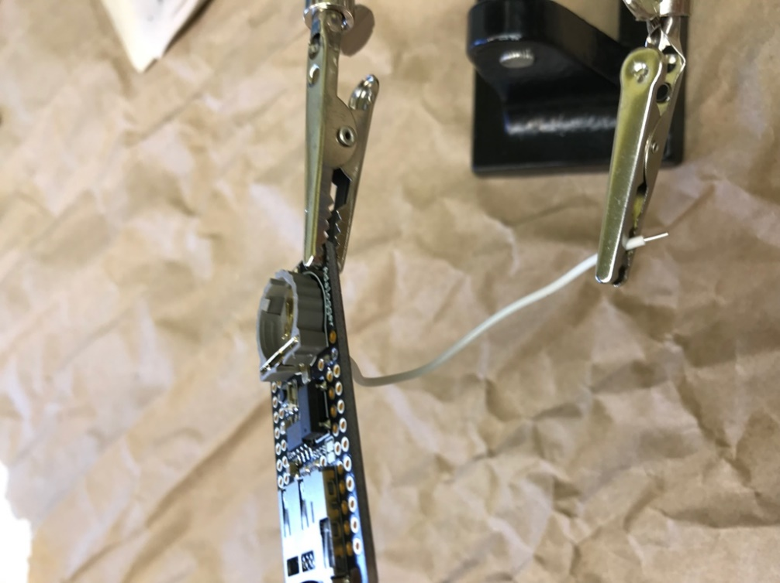

The Adalogger appears as follows from the feather side.

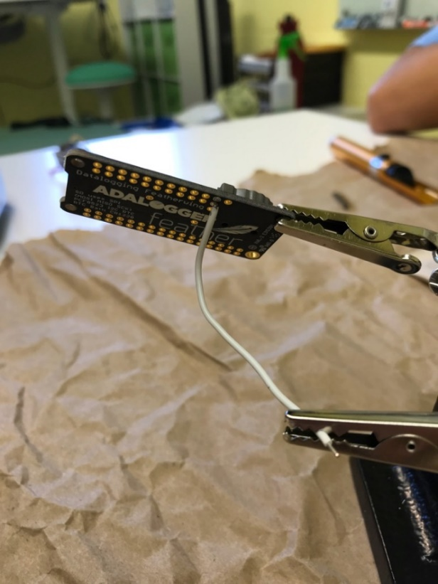

Solder the barometer wires to the Adalogger (red to 3V, black/green to ground corresponding to the Feather; use inner holes). Insert wires from the feather side, and solder from the add-ons side. The Adalogger with the red wire soldered appears as follows from the add-ons side.

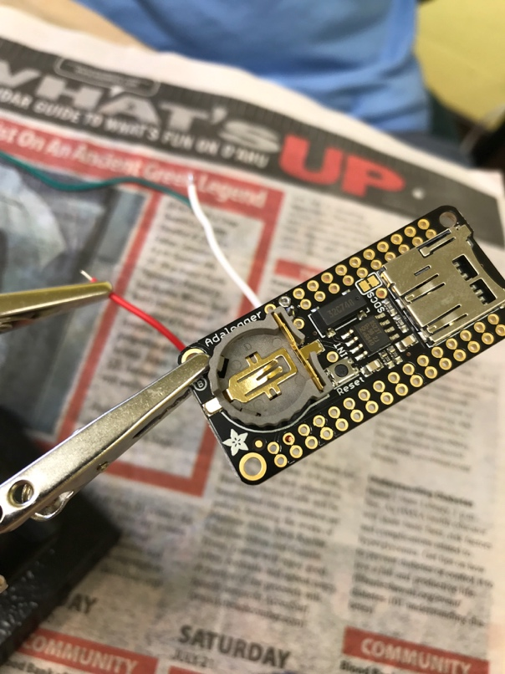

The Adalogger with the green wire soldered appears as follows from the add-ons side.

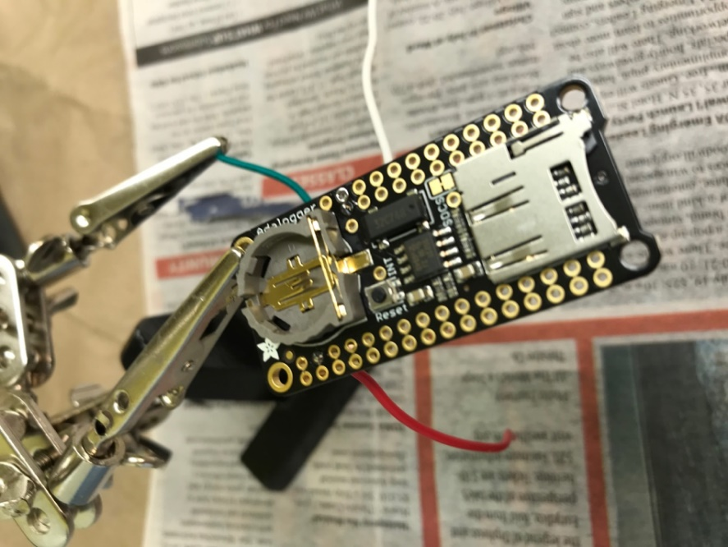

Continue with the barometer wires. Solder the wires to the inner holes corresponding to Feather SDA and SCL, which are right next to each other. The Adalogger is depicted from the add-ons side with the SCL wire soldered.

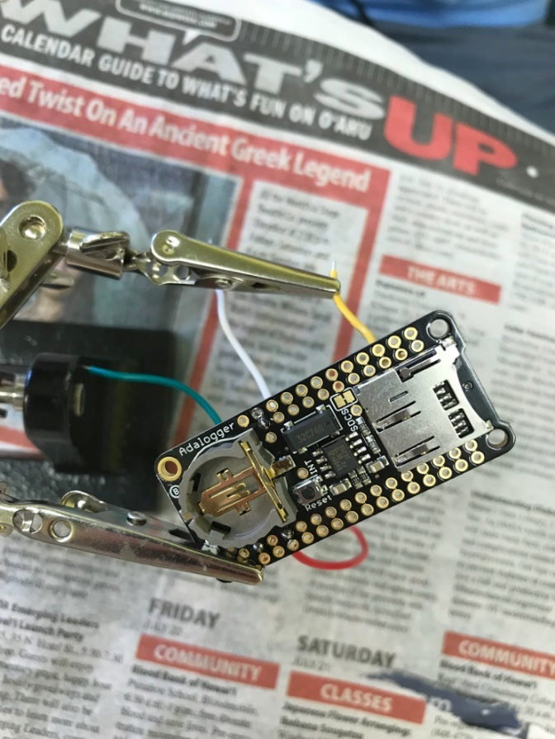

The Adalogger is now depicted from the add-ons side with the SDA wire soldered.

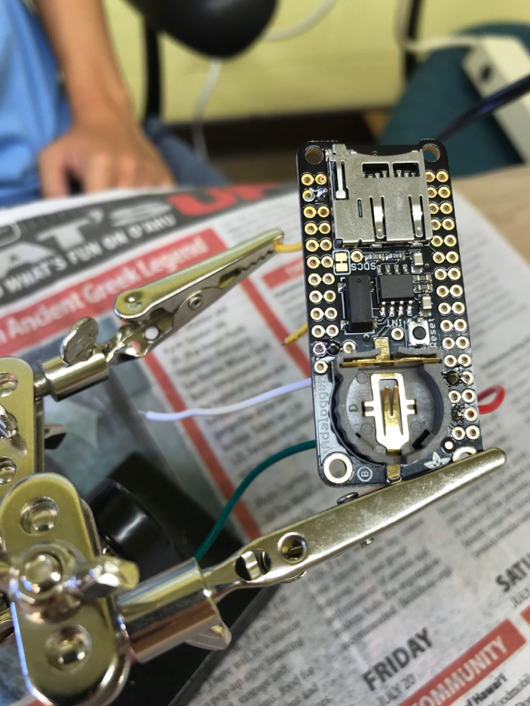

The Adalogger should now appear as follows from the feather side.

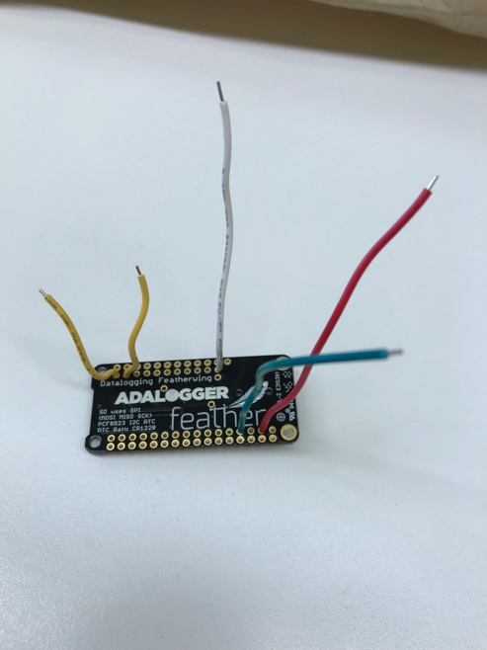

Here is a closer view.

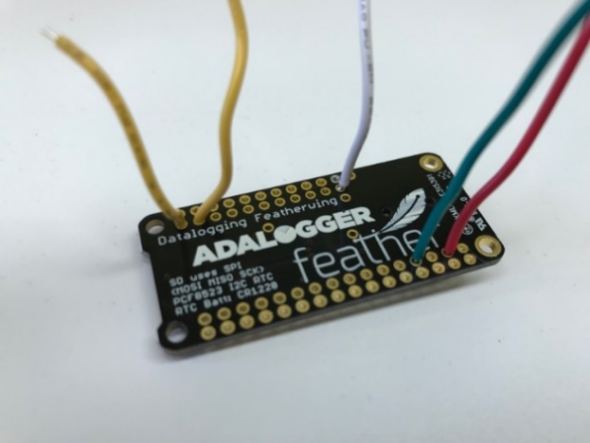

Here are the Adalogger and the Feather at this point in the building process. Note that the feather side of the Adalogger and the USB side of the Feather are being shown:

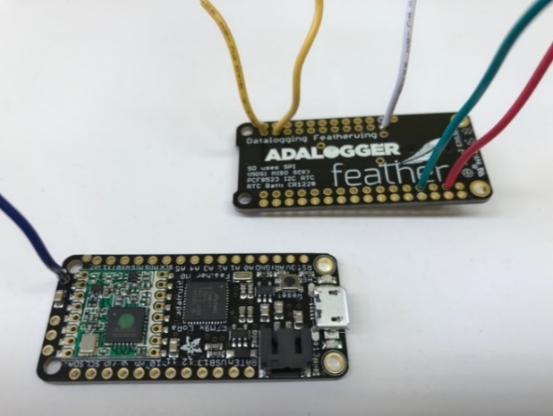

The humidity sensor will sit on the outside of the mini-GNI’s 3D casing. To set it up for soldering, feed the humidity sensor wires through the hole on the mini-GNI casing (see below). The humidity sensor will sit on the outside, and wires will be inside.

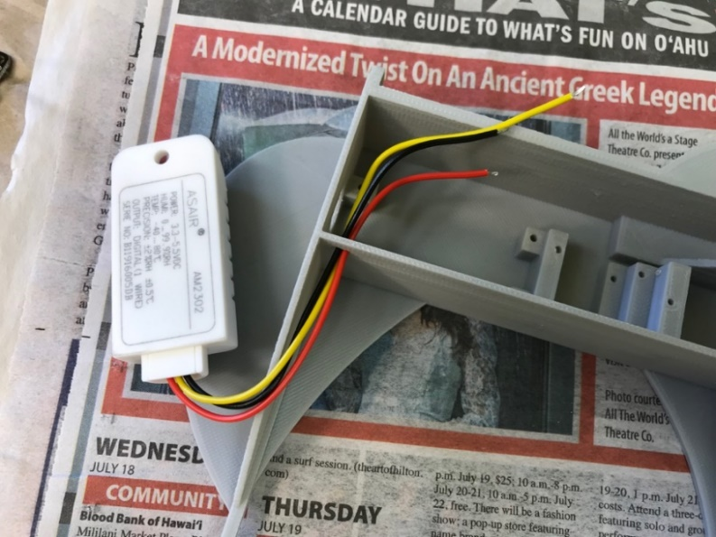

The yellow humidity sensor wire is soldered to the Adalogger (inner hole) corresponding to D6 on the Feather from the feather side to the add-ons side. The other two wires on the humidity sensor will be attached to add-ons side of the Adalogger after the header has been soldered.

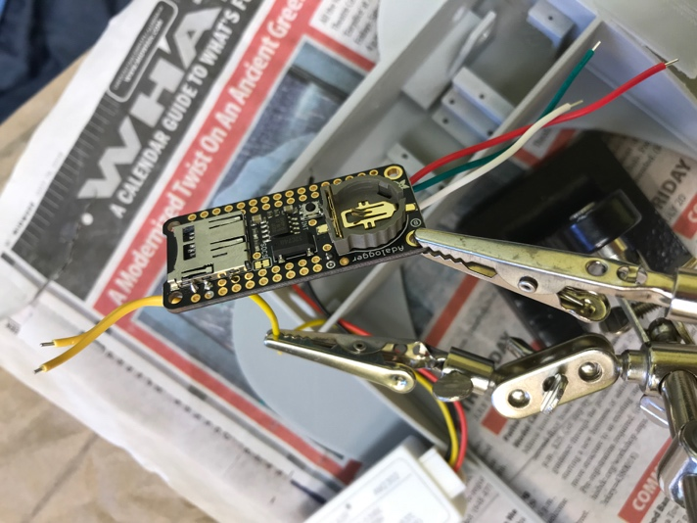

Next, solder the servo motor wires. The yellow servo motor wire is soldered to the Adalogger (inner hole) corresponding to D9 on the Feather from the feather side to the add-ons side. D9 is right next to D6. The Adalogger is depicted from the add-ons side.

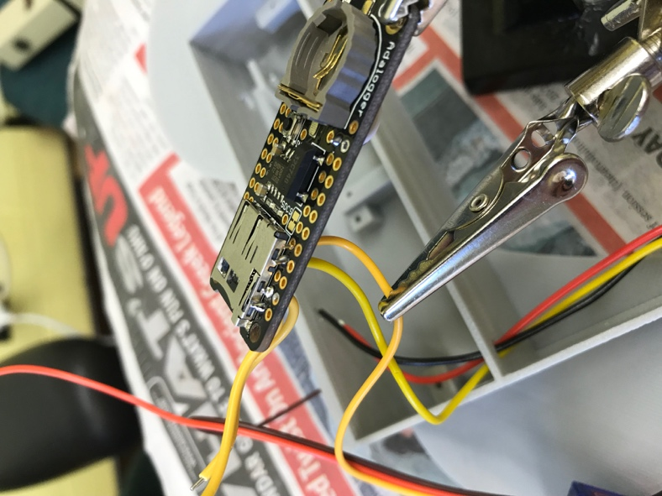

Here is a side view of the current progress. Four barometer wires, one power switch wire, one humidity sensor wire, and one servo motor wire are now attached to the Adalogger.

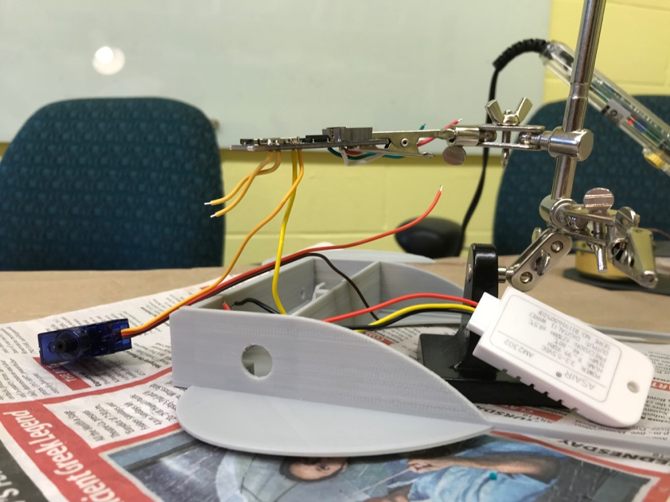

Solder the female headers to the Adalogger. This requires 12 solder points on one side and 16 on the other. Both headers on the Adalogger are depicted below.

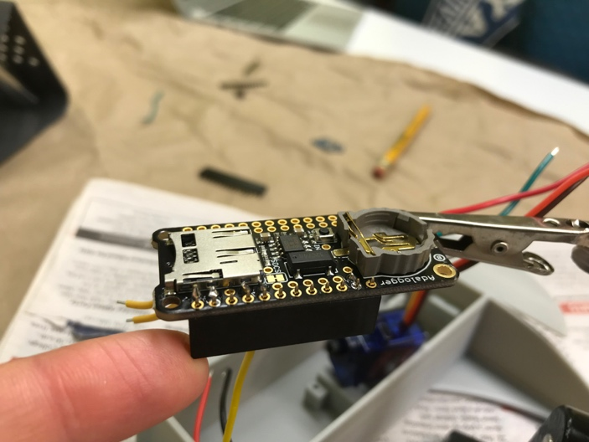 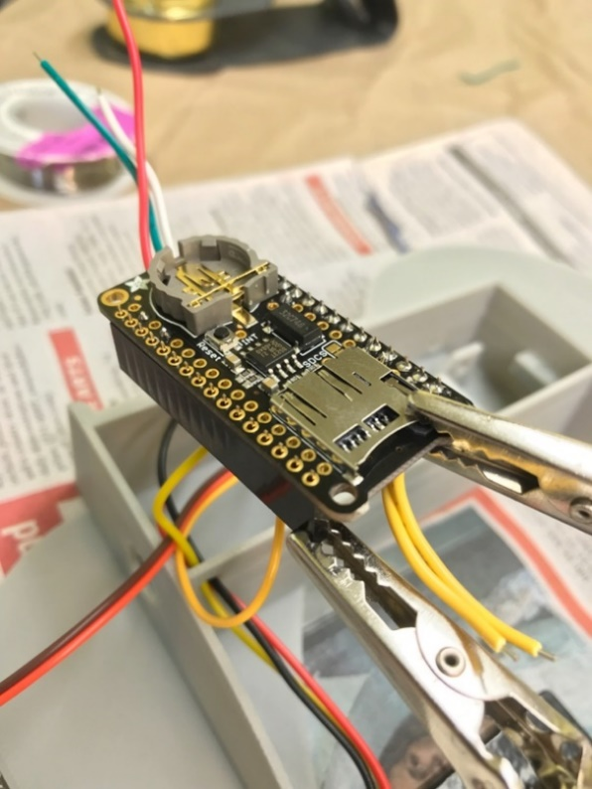

Male headers come in a length of 16. Break off 4 on one male header, you only need 12 for one side of the Feather. Insert the male headers into the female headers for soldering to make sure they’re well aligned as depicted below.

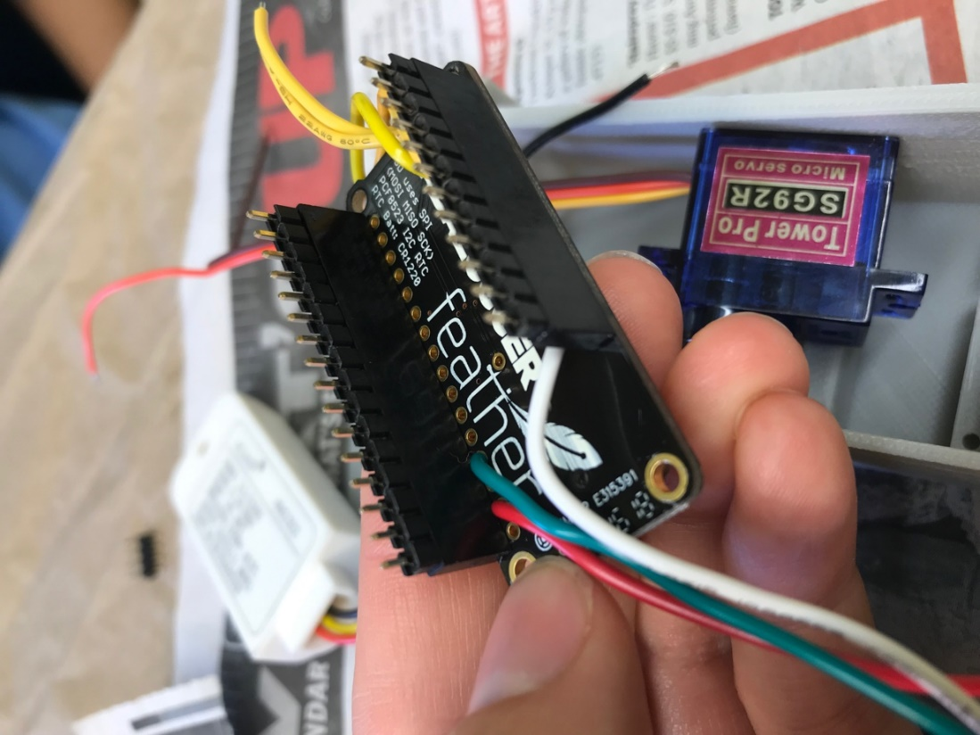

Connect the Feather to the short side of the male headers and solder all 28 pins.

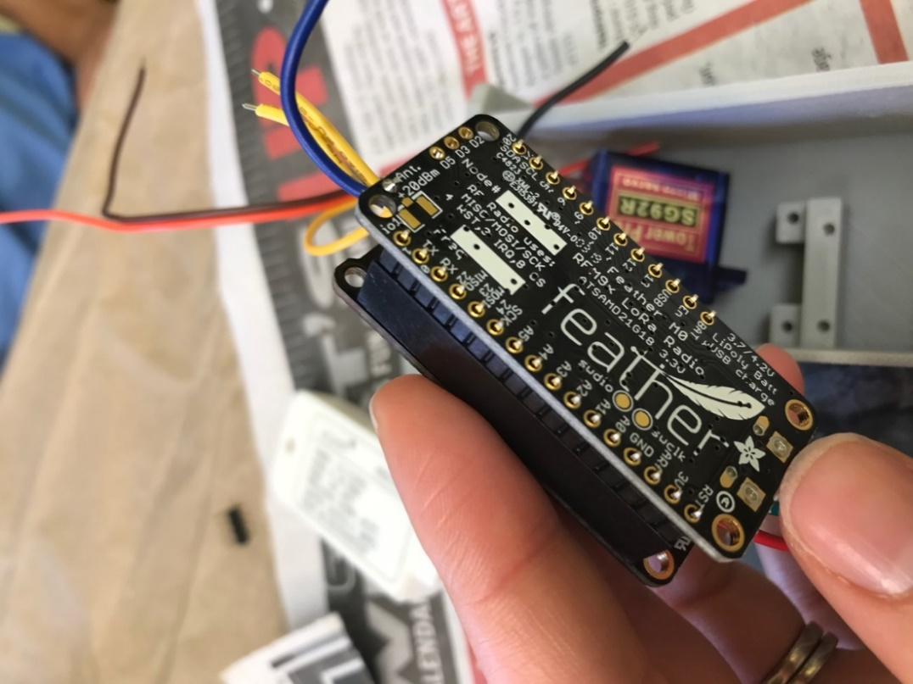

Now separate the Feather from the Adalogger. Rearrange the wires so they come out of the correct ends of the Feather – Adalogger unit. Notice how all wires go towards the end of the Adalogger with the micro-SD add-on except for the yellow humidity sensor wire.

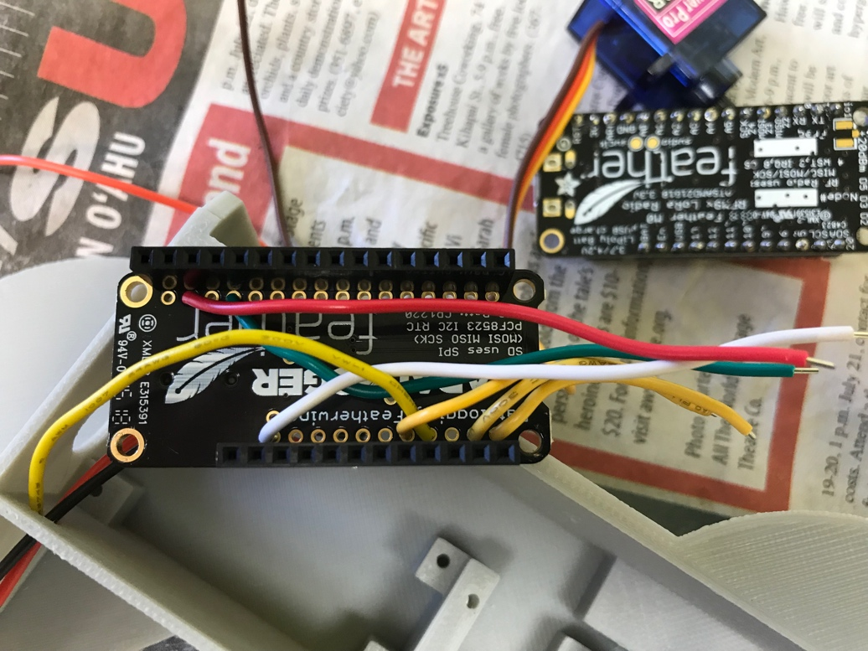

Wind the antenna wire around a pencil so it is shorter and out of the way.

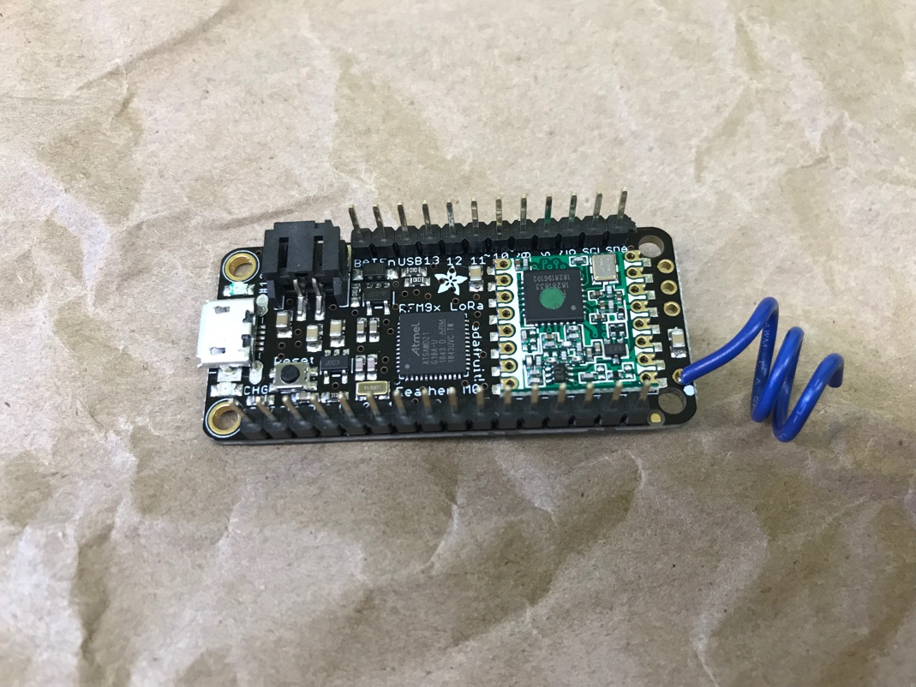

Reattach the Feather to the Adalogger, with the wires sticking out of the appropriate ends. Arrange the pieces with the mini-GNI to verify that it is assembled correctly.

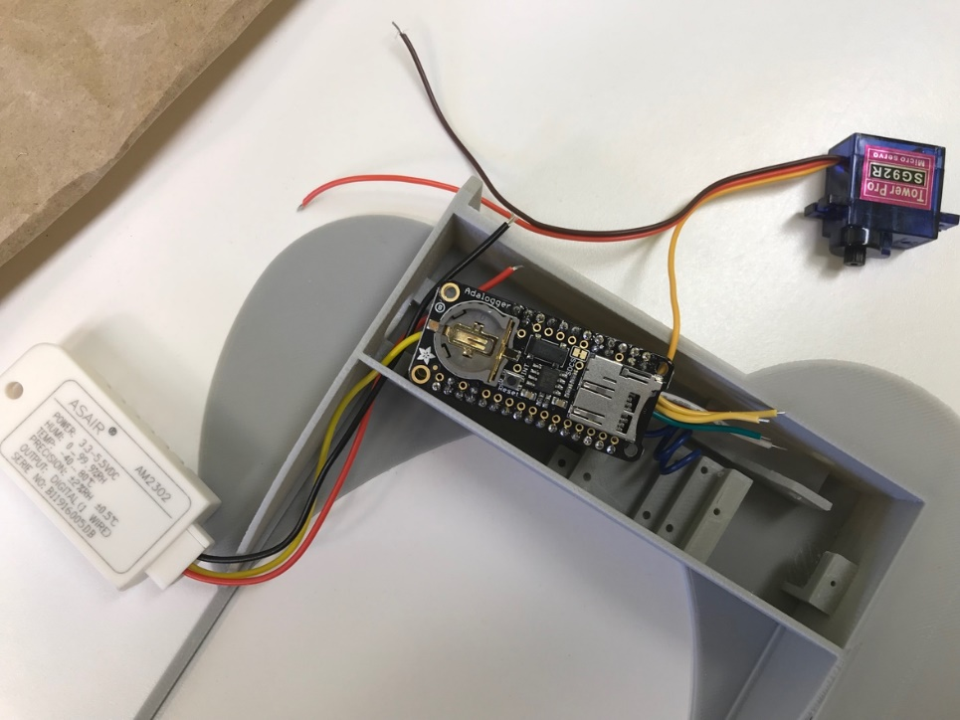

Connect the red and brown wires from the servo motor directly to the pins on the feather side of the Feather. Red goes to 3V and brown goes to ground. These connections cannot be made to the inner pins because the barometer wires are already connected to those locations.  You have two options - splice the wires together or connect from the wire directly to the pin.  Here we choose to make a connection from the wire directly to the pin. If you choose to also make connections directly from the wire to the pin, add solder to the wire and add solder to the pin. Connect the two as shown. Do this for both the red and the brown wires from the servo motor.

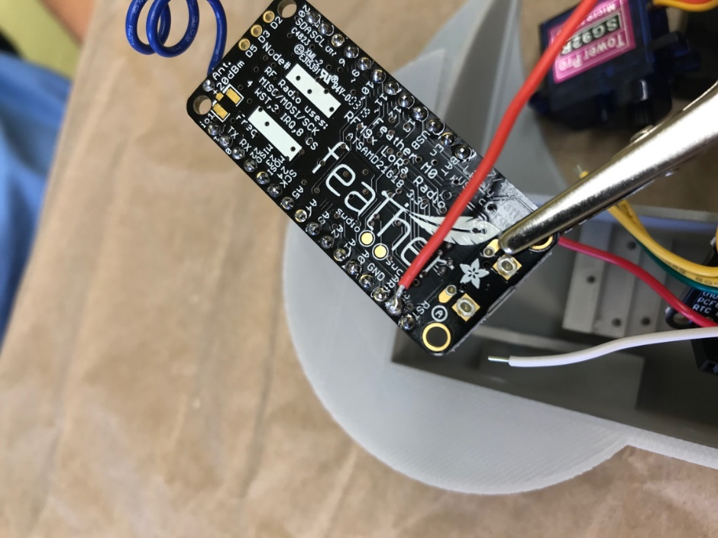

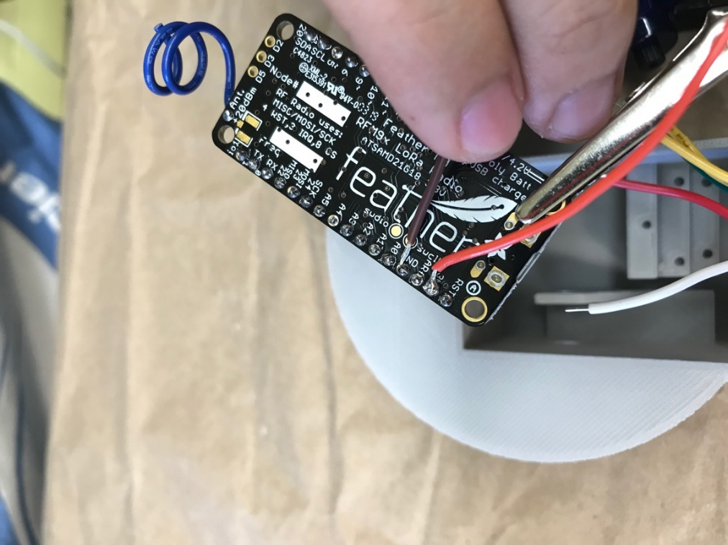

Connect the barometer wires that were soldered to the Adalogger earlier to the barometer sensor. Insert the wires from the side labeled “altimeter” to the side with the image of a star. Solder the yellow SDA wire to SDA on the barometer, yellow SCL to SCL, red to power (labeled “VIN”), and black/green to ground (“GND”).  The power and ground wires were cut longer than the yellow wires because they come from the opposite end of the Adalogger as compared to the yellow wires which are nearby.

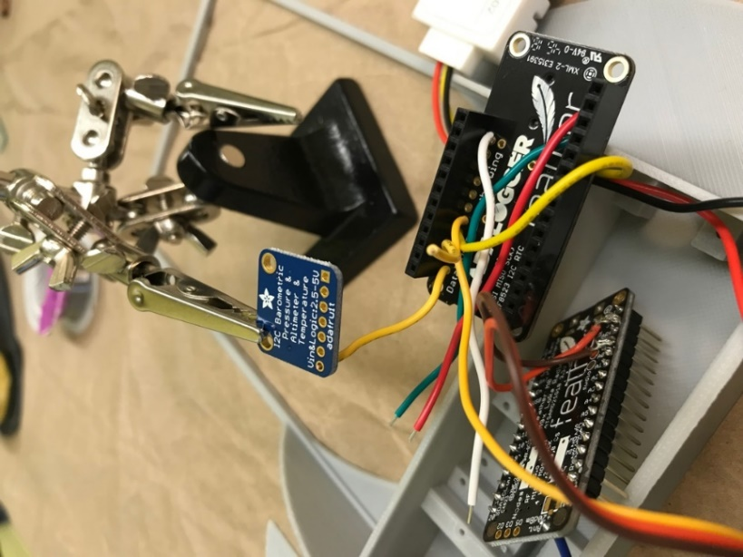 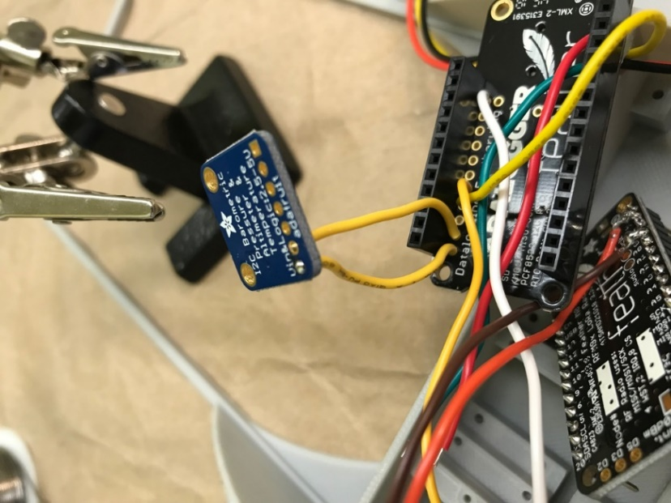

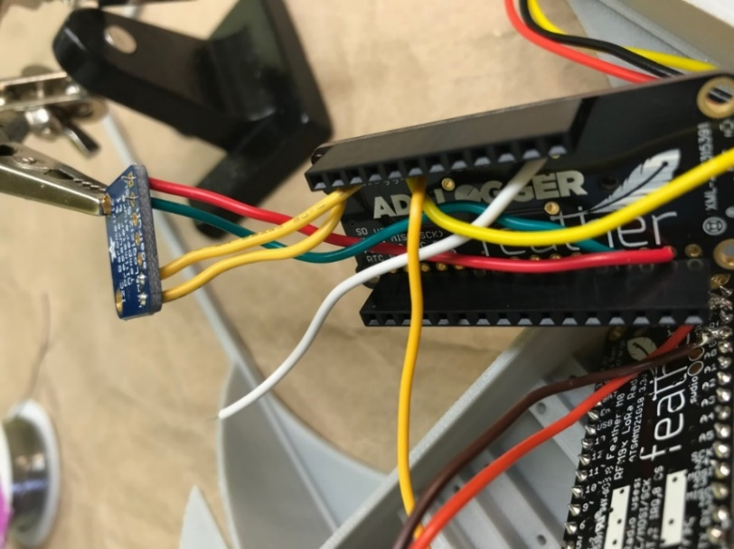

Here are images of the barometer attached to the Adalogger:

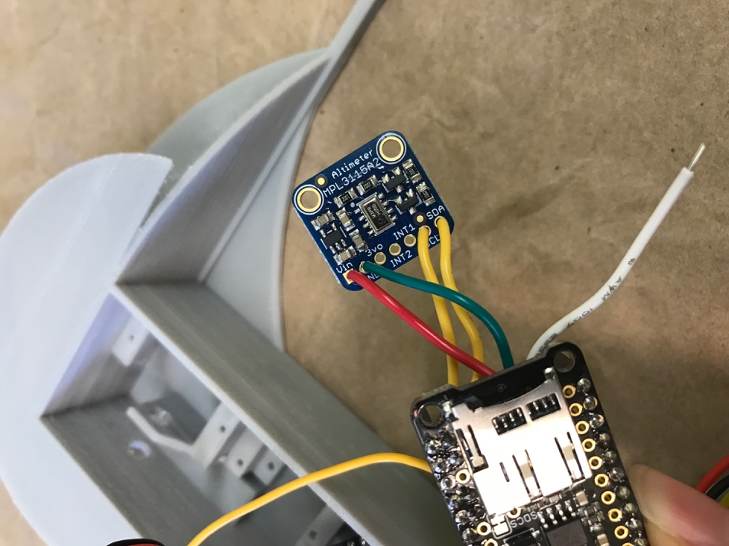

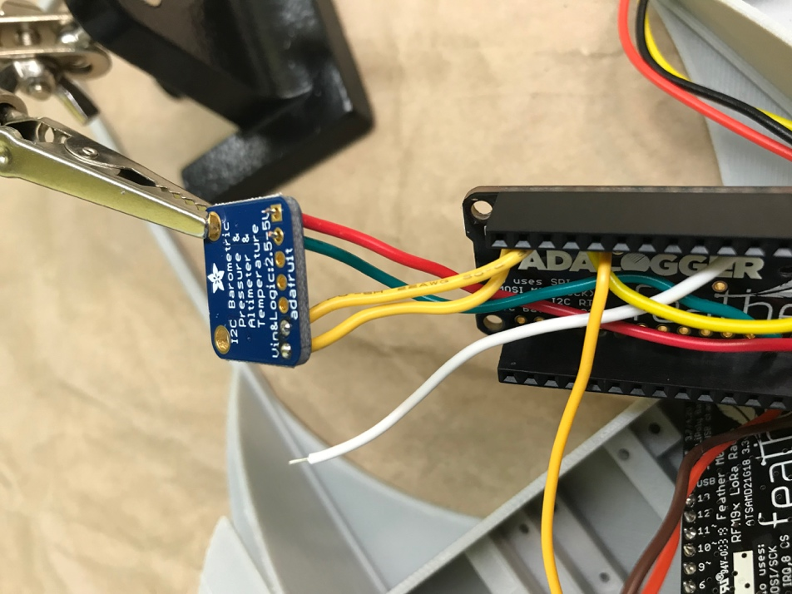

Now it is time to begin assembly of the mini-GNI. Pop the Feather and Servo motor into place. Note the orientation of the servo motor. Place the wires from the servo motor alongside it.

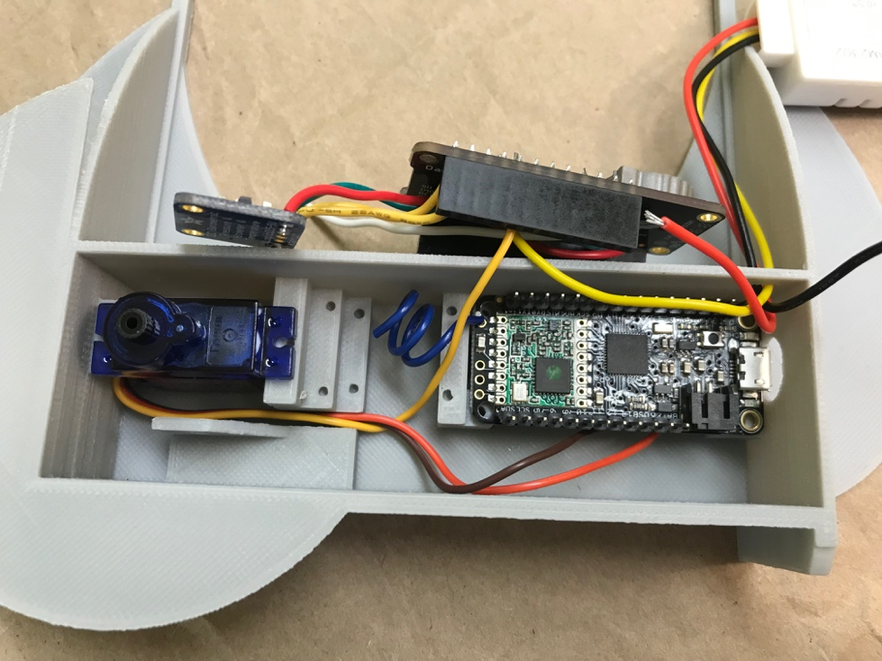

Screw in at least 2 of the 4 holes of the Feather, opposite corners preferred.  Screw in both sides of the servo.

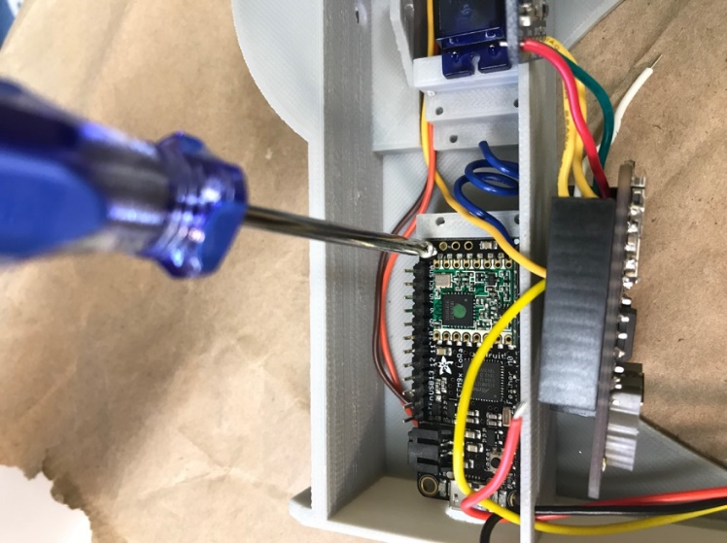 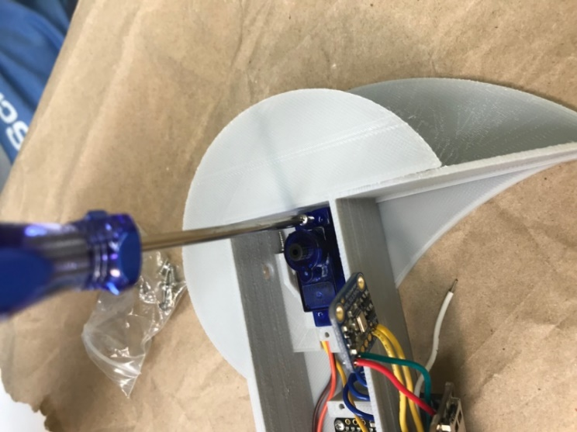

Reconnect the male headers from the Feather to the female headers from the Adalogger.

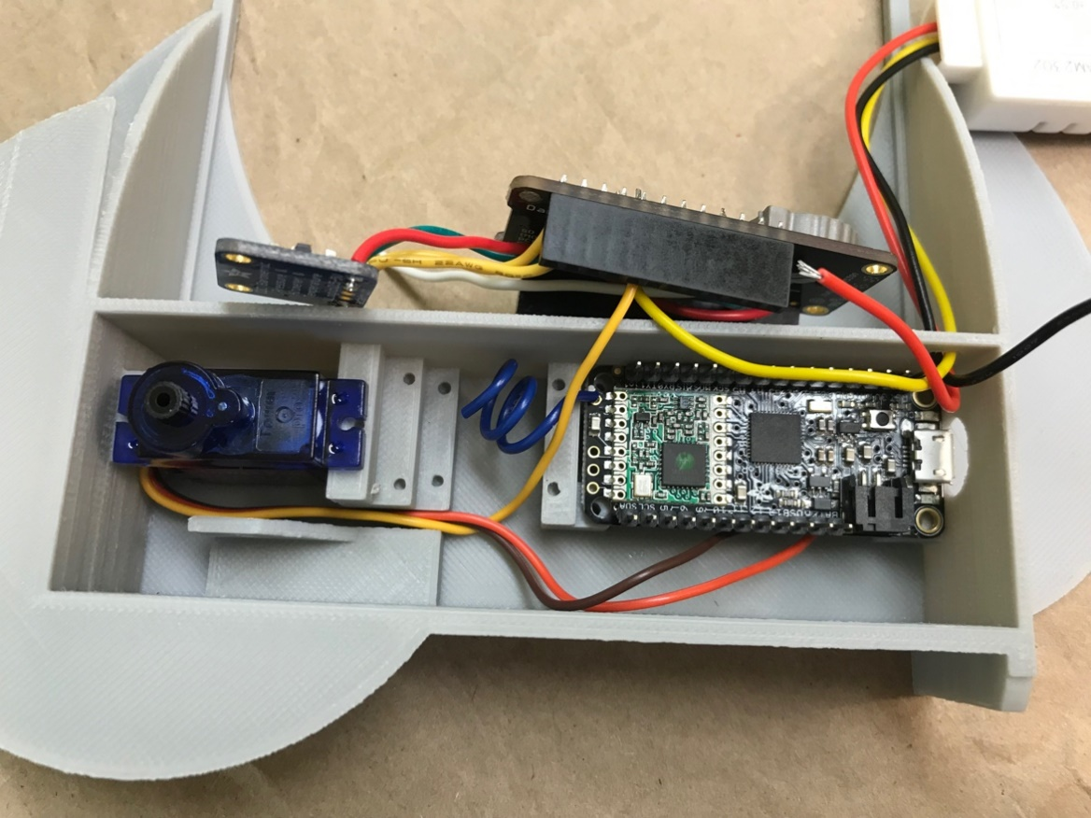

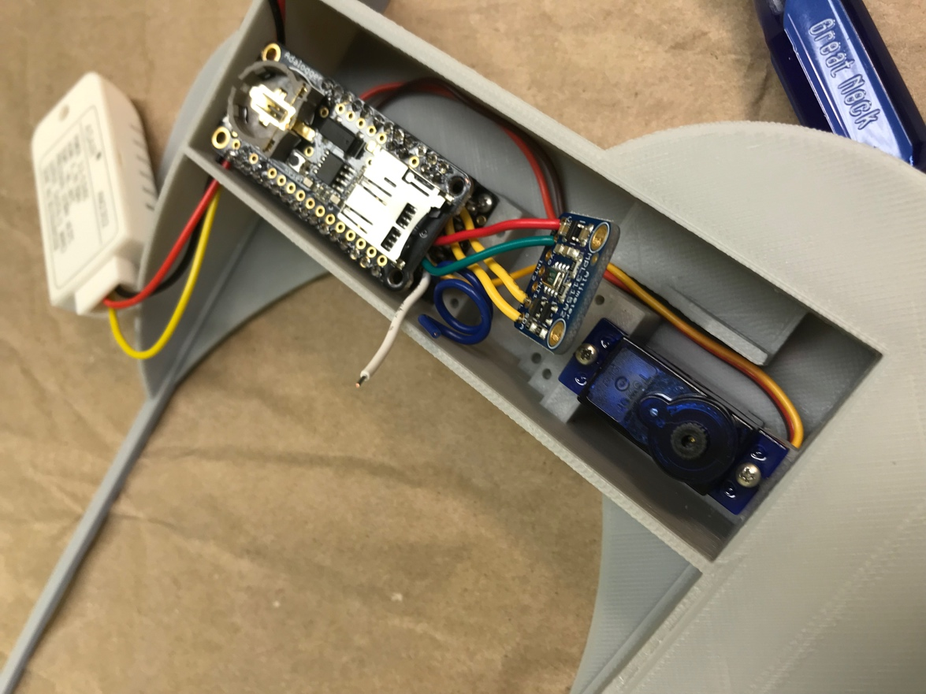

Push the barometer into its place on the mini-GNI. Use at least one screw to hold the barometer in place.

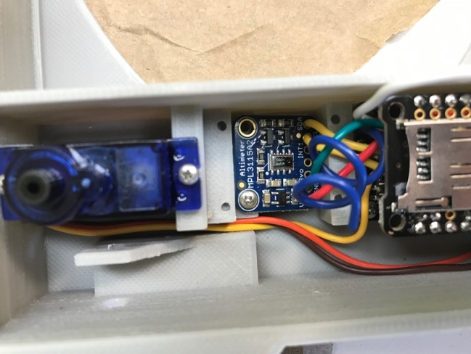 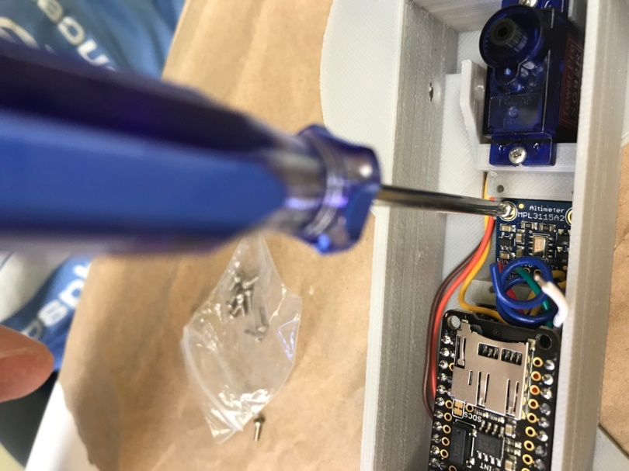

Now it’s time to add the power switch. It consists of 3 small pins that are 2.5 mm apart. Holes need to be drilled for it to be installed. The holes can be drilled beforehand, or you can do it at this point in the process. Mark a position on the outside of the mini-GNI, above where the barometer is, where the switch will be placed. This is not added to the 3D print design due to the size of the holes.

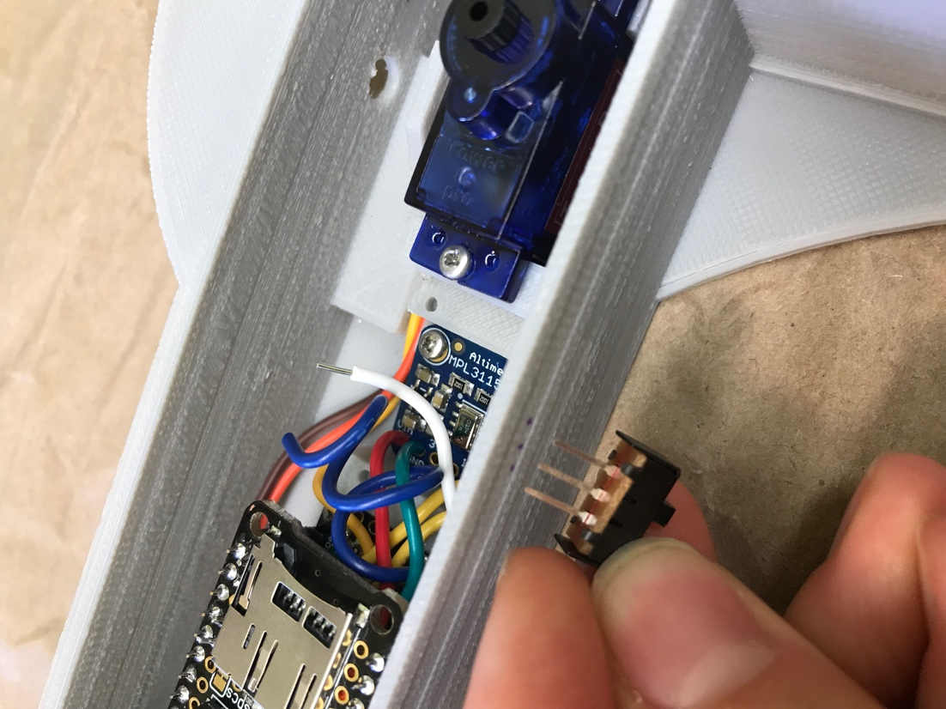

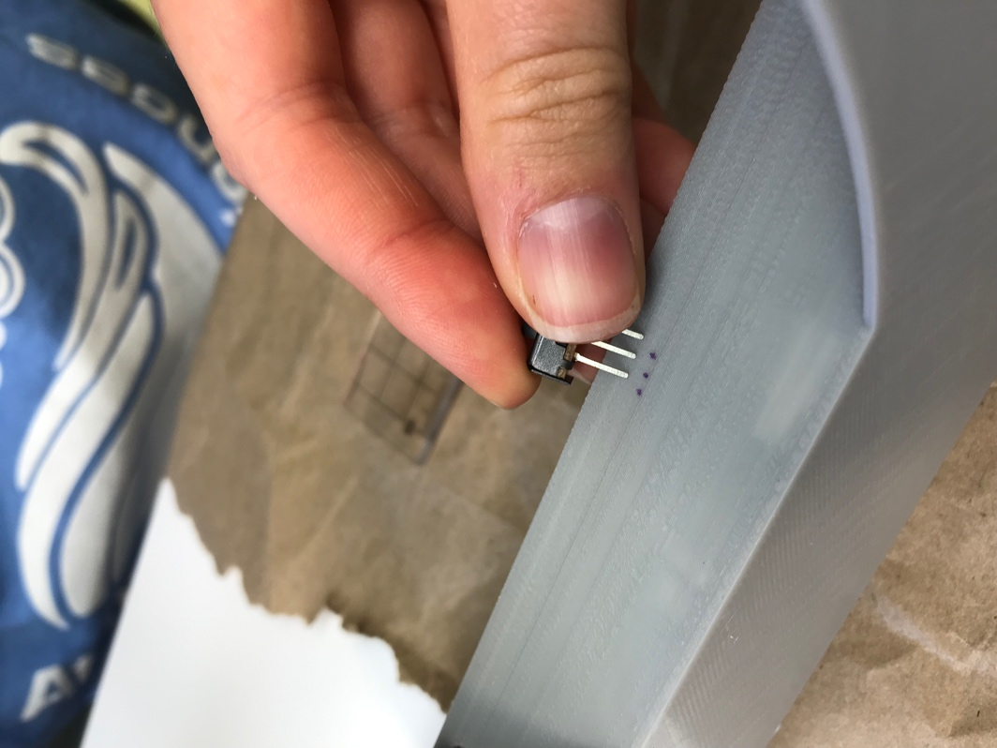

Drill holes with a 1/16th inch drill bit in the three positions marked.

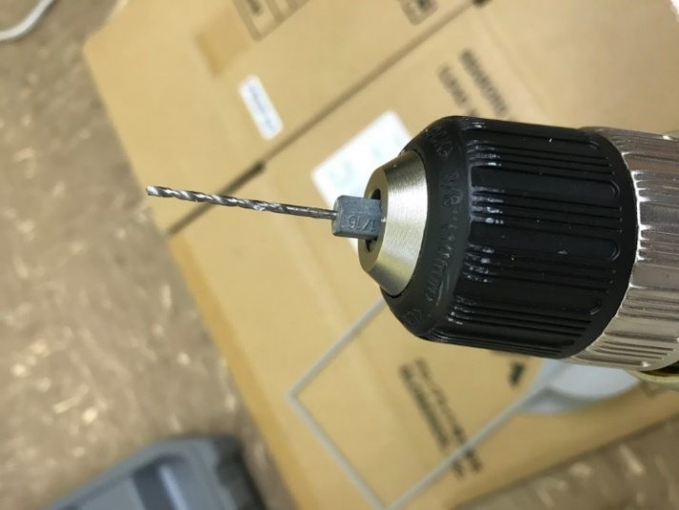

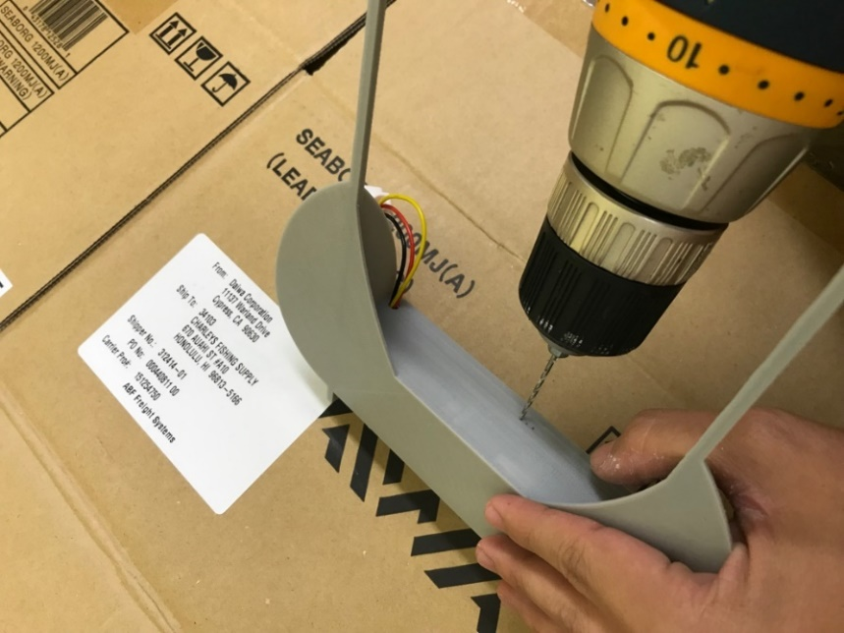

Insert the power switch and bend the pin that is farthest away from the Feather backward. Only two of the pins are needed (only two positions: “on” and “off”).

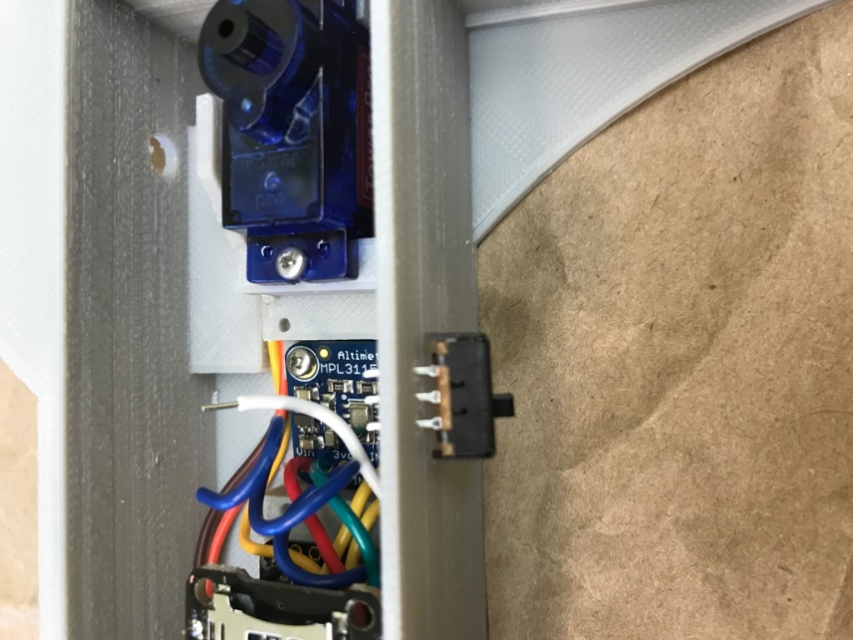

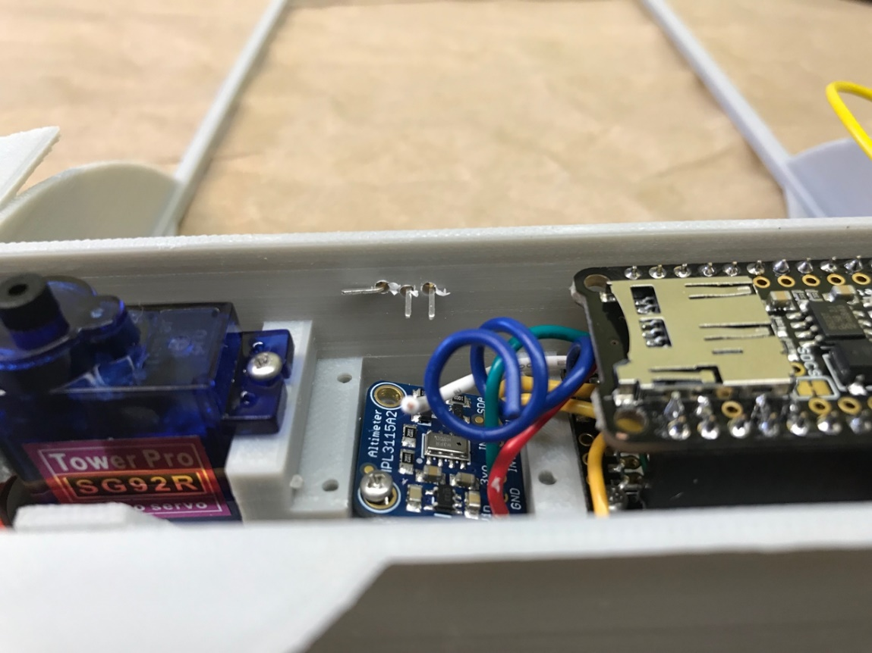

Take the unused black/green 7-cm power switch green and solder one end to the middle pin of the switch. Add solder to both the wire and to the pin to make the connection.

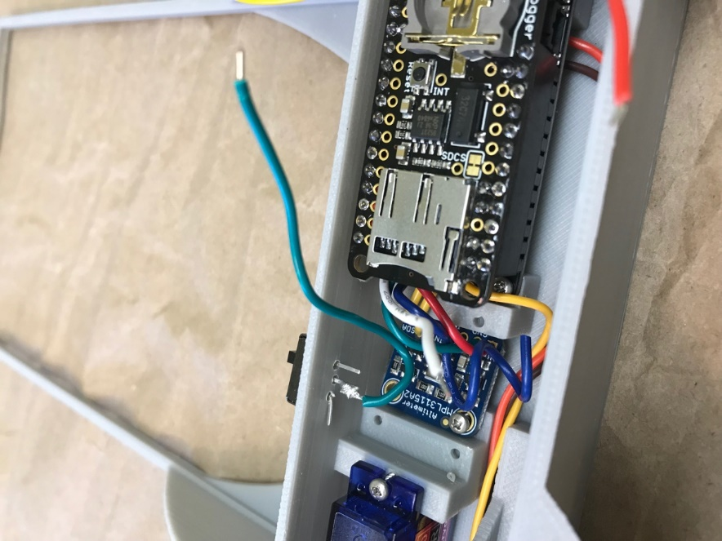

Two connections need to be made to the ground pin on the top of the Adalogger: the black wire from the humidity sensor and the black/green wire from the power switch. These connections are again direct pin to wire connections. Tuck the black/green power switch wire alongside the header pins of the Adalogger.

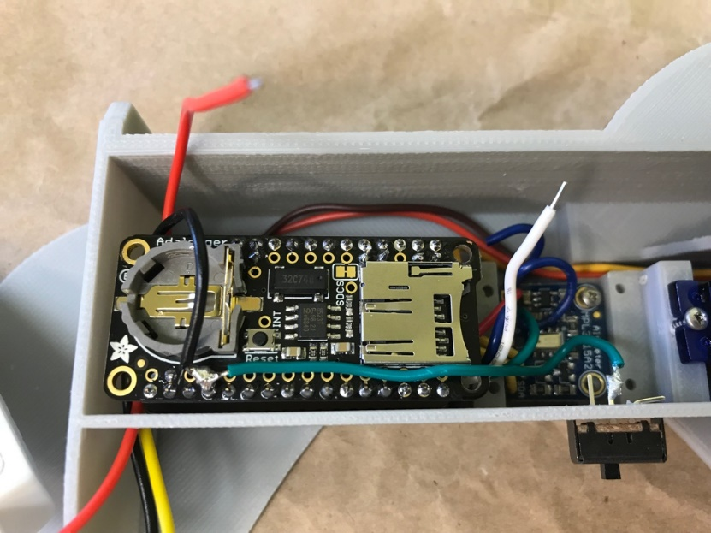

This allows us to finish connecting the humidity sensor. Now connect the red wire from the humidity sensor to the power pin on the top of the Adalogger.

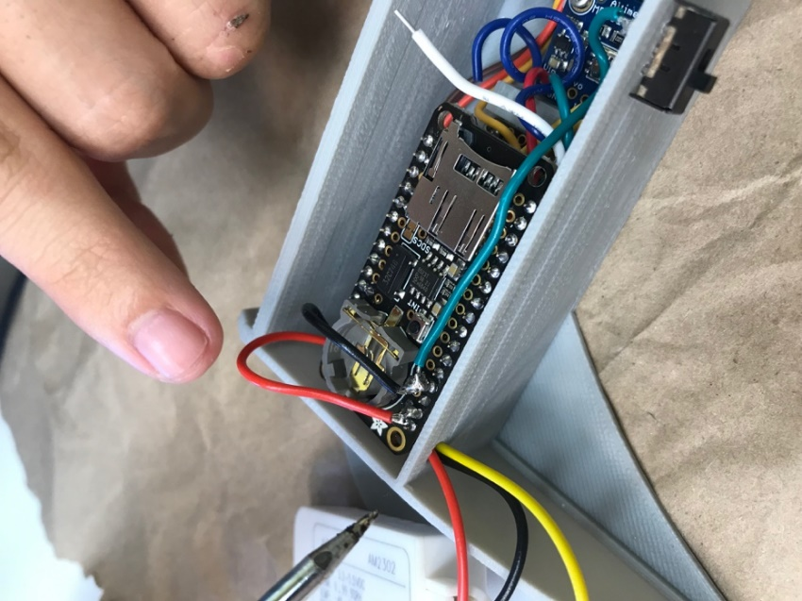

Once the red and black wires from the humidity sensor are connected, tuck them to the side of the coin cell battery add-on, and pull the excess wire out the hole to outside of the min-GNI.

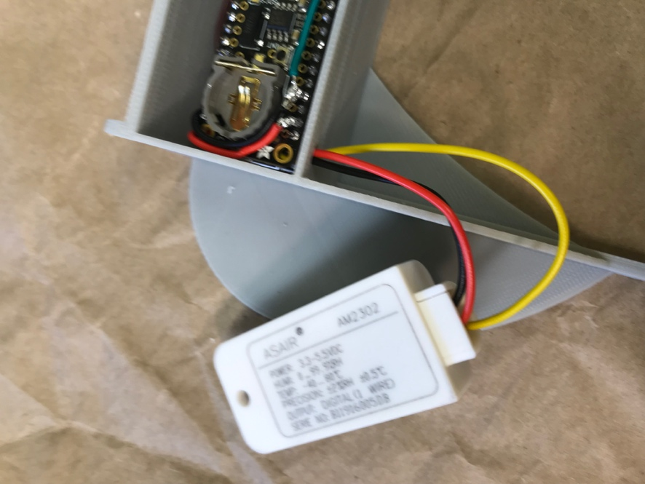

Now for the last solder connection. A power switch wire was soldered at the beginning to the Adalogger hole corresponding to “En” on the Feather. The other end of the white wire is now soldered to the end pin of the power switch. Again, this is a pin to wire connection.

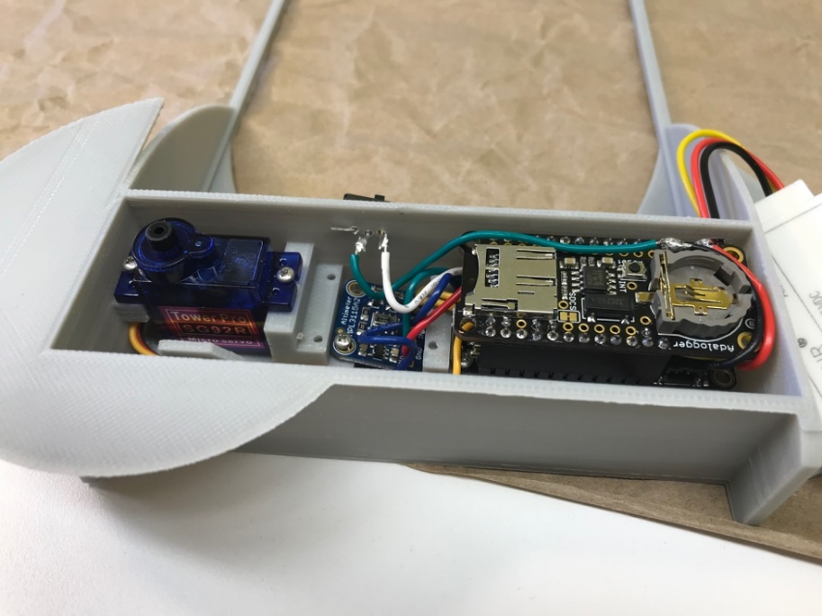

On the outside of the mini-GNI, label “Off” and “On” for the power switch. The “On” position is towards the middle pin while the “Off” position is towards the end pin.

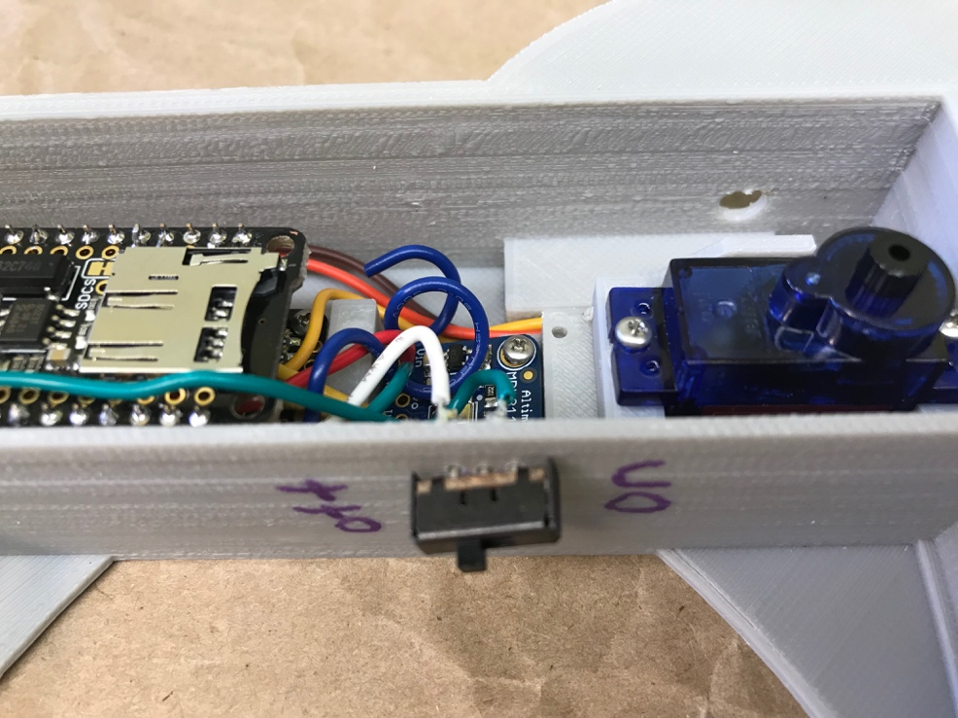

Now it is time to connect the arm and the door. Gather parts for the arm connection: 3D printed arm, wire spring, clevis and cotter pin.

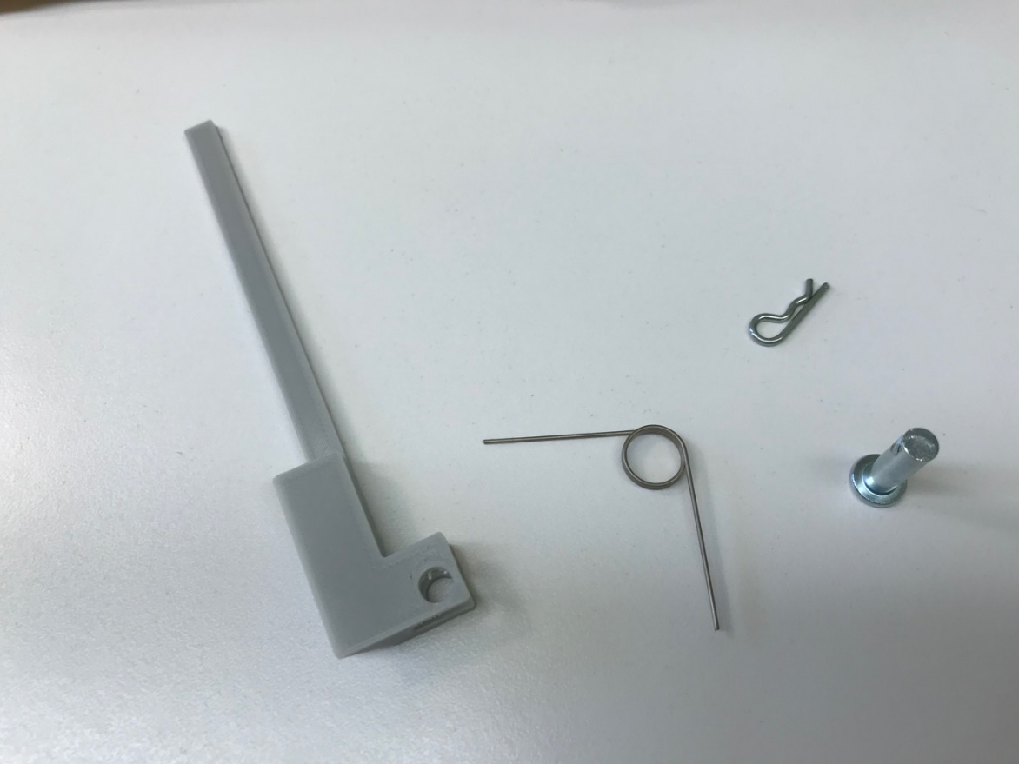

When assembled, it will look like this, but it will be inside of the mini-GNI:

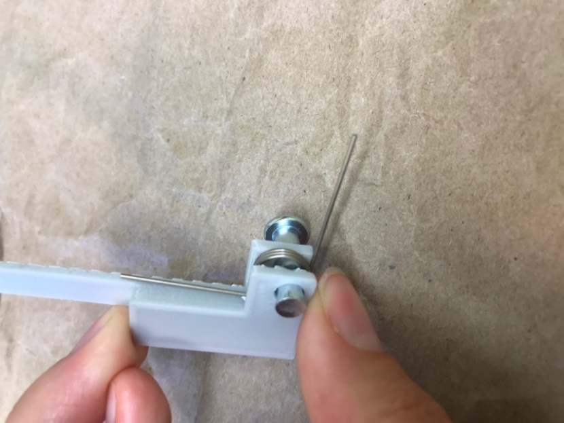

The arm holes line up with the holes in the mini-GNI, with the slanted side facing the wall of the mini-GNI (see photo below).  Put everything in place and insert the cotter pin into the hole.

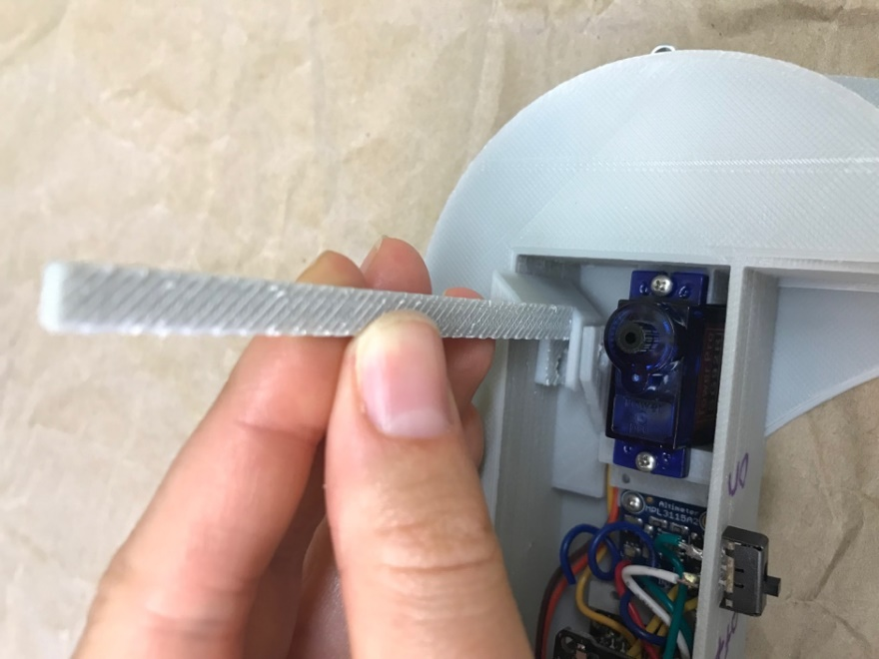 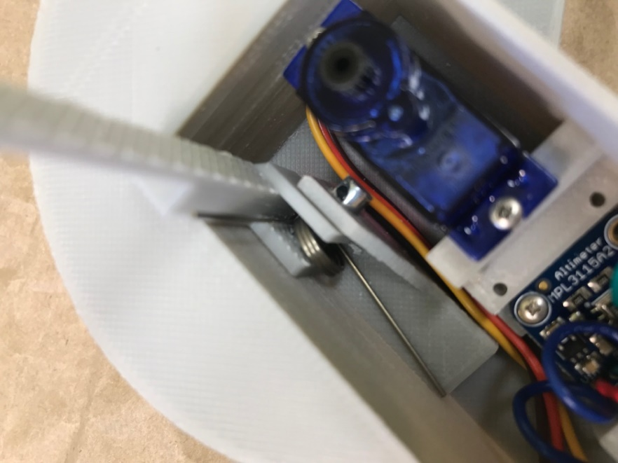

Now add the batteries and the microSD card. Place the 3.7 V 150 mAh Lipo battery alongside the servo motor. Plug the other end into the Feather M0 with a pair of pliers since it’s hard to reach down into the mini-GNI at this point. Tuck the wires down as best as possible so they don’t interfere with the movement of the moving arm.

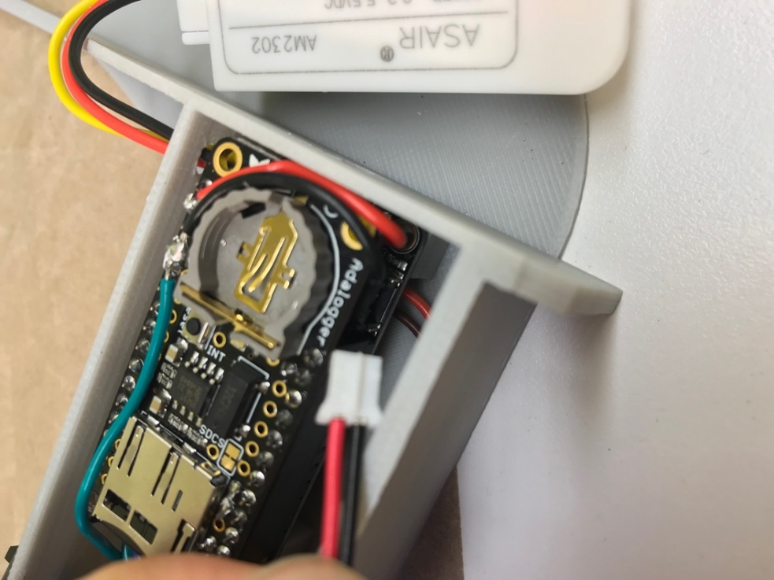

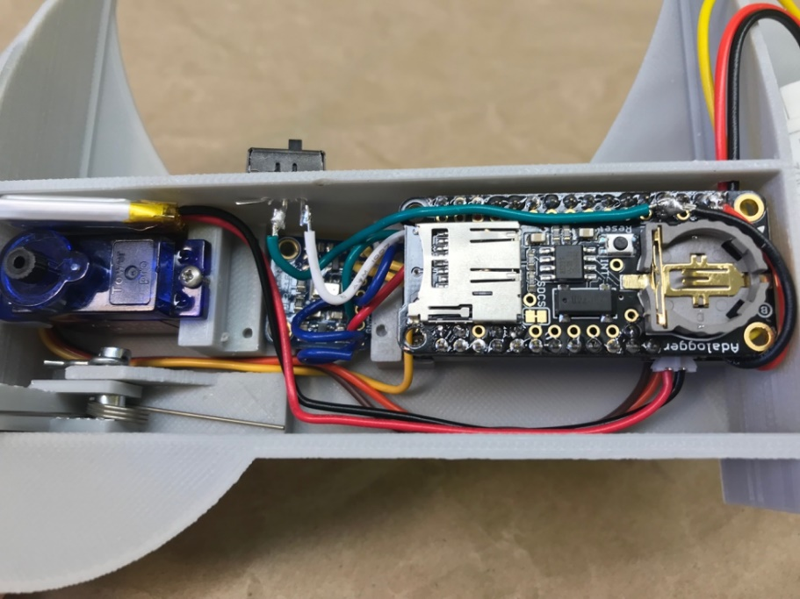

On the Adalogger, insert the coin cell battery into the slot of the RTC add-on, and insert a micro-SD card into the micro-SD add-on.

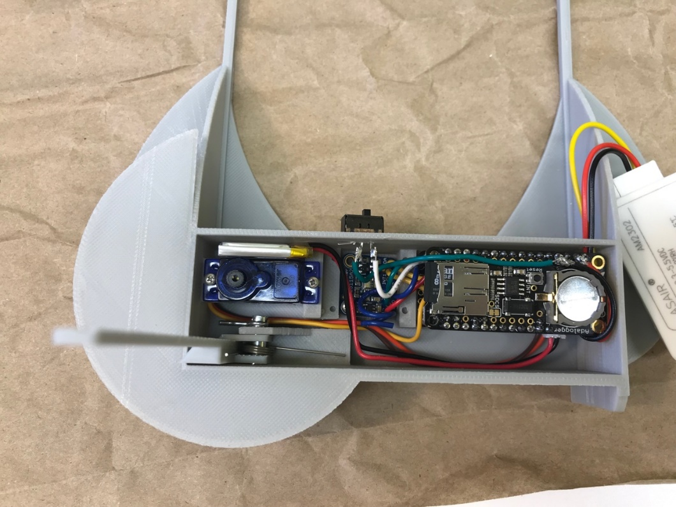

All that is left is to add the door. Snap a servo motor attachment into the hole on the door.

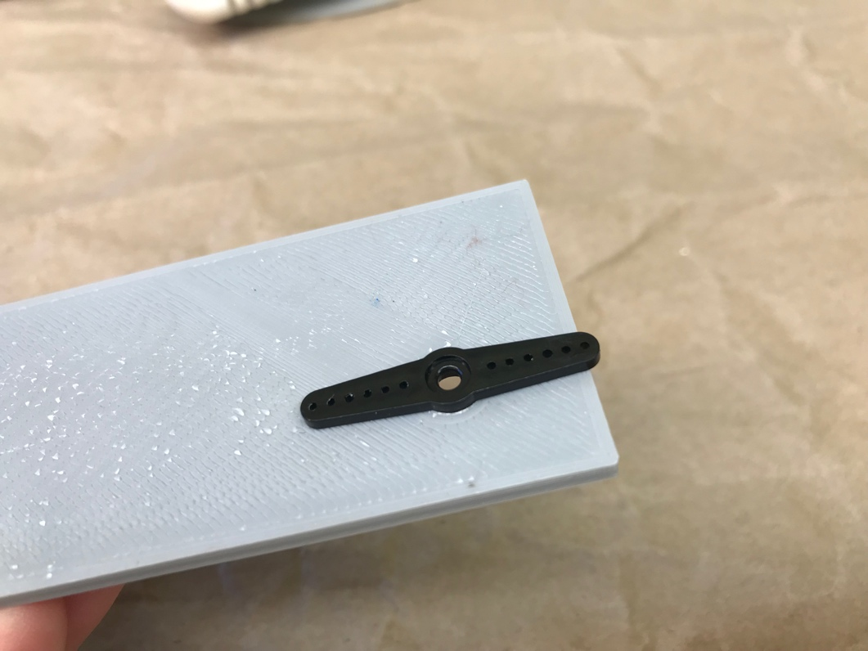

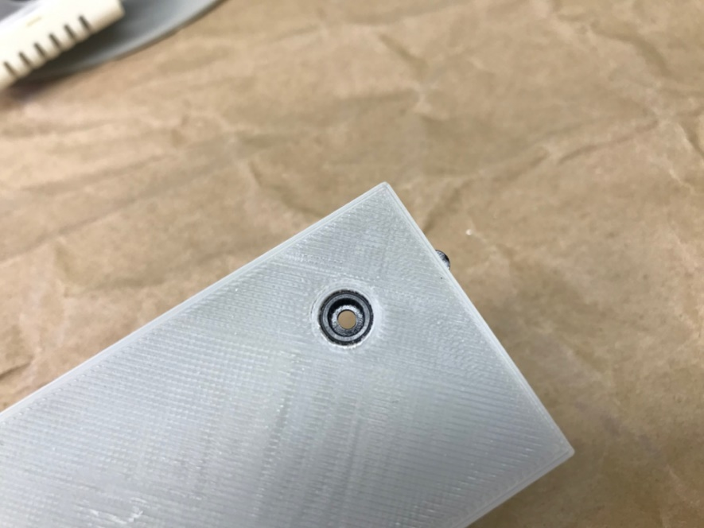

Fold the arm down and snap the servo motor attachment onto the servo motor.  It should snap in place firmly.  Otherwise, use glue.

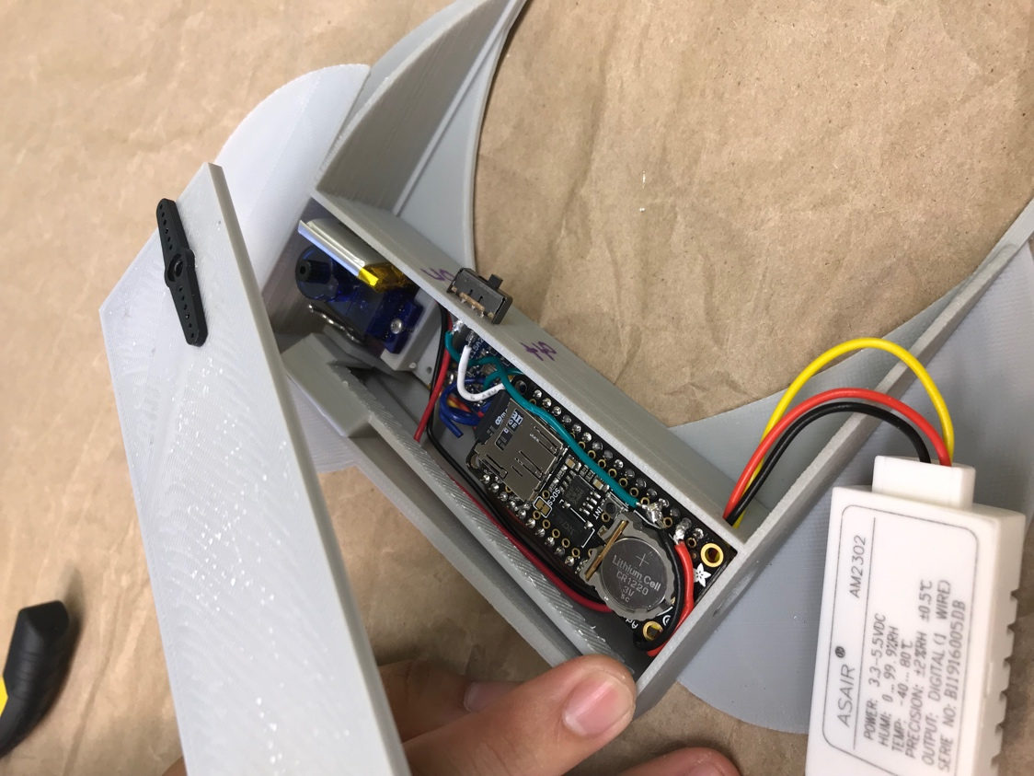

Use a screw to hold the servo motor attachment down.

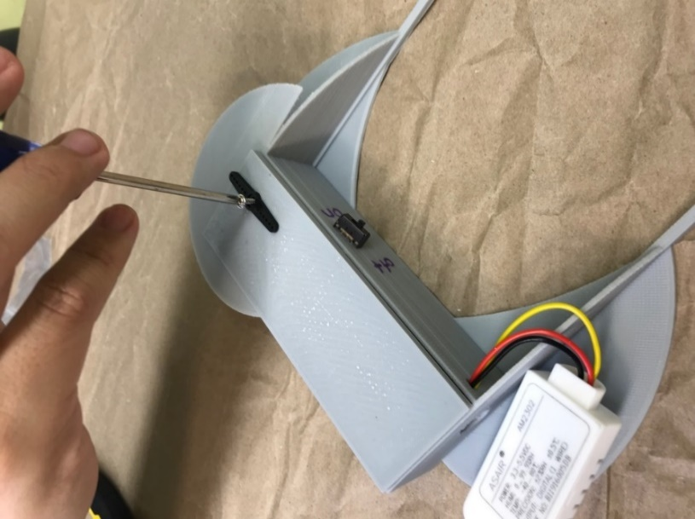

Check that the door will open and close manually. Make sure the arm pops out when opened.  If there are rough parts, sand as needed.  This is important; the door must slide open and shut unimpeded!

Now use adhesive putty to stick the humidity sensor to the outside of the mini-GNI.

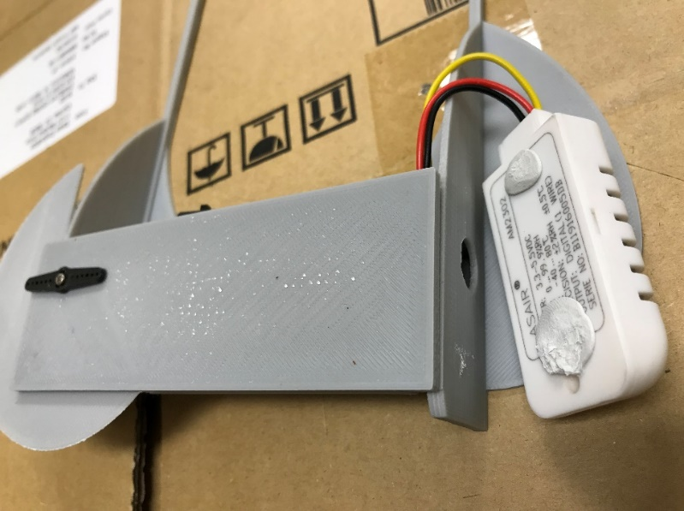 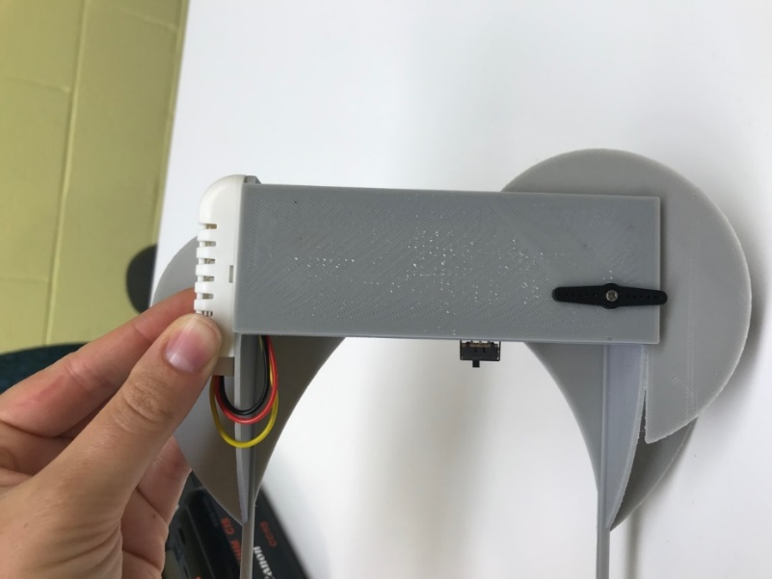

Use adhesive putty to close off the two holes where the power switch inserts into the instrument.

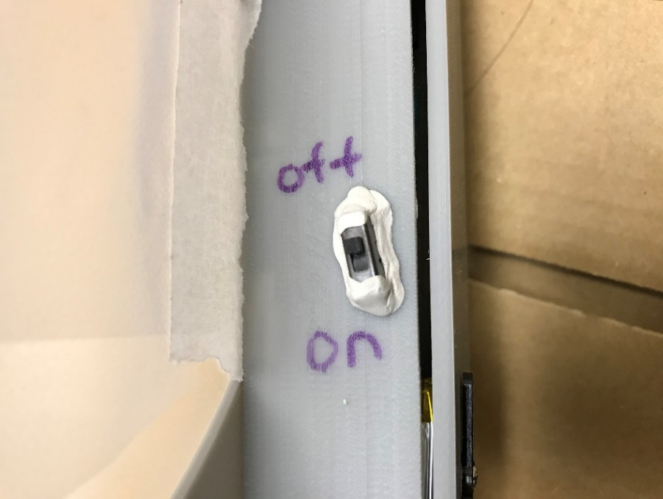

Now we will cover the wing of the instrument using a thin layer of plastic. Here we use Glad Press ’N’ Seal. Lay the mini-GNI on the plastic wrap.

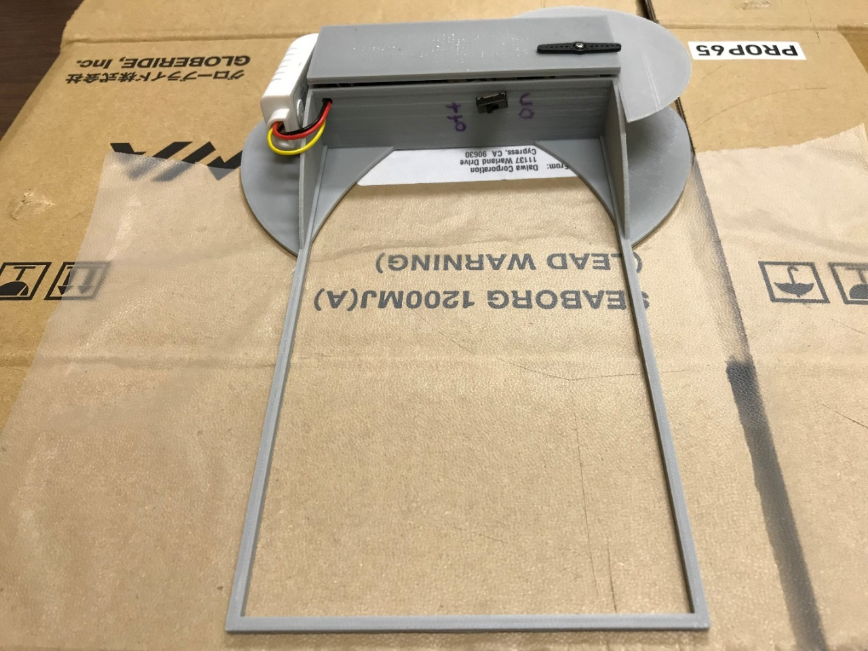

Cut the saran wrap around the round sides of the mini-GNI so that the saran wrap can be folded around the wing.

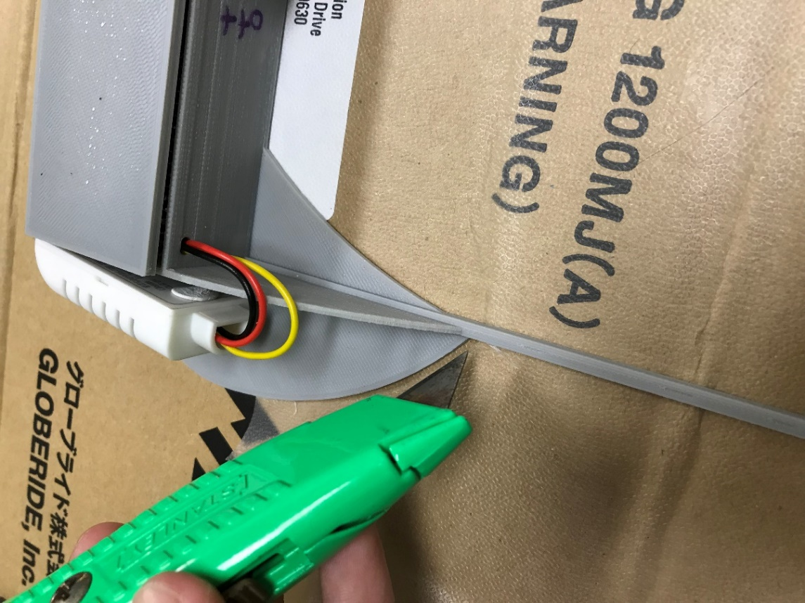

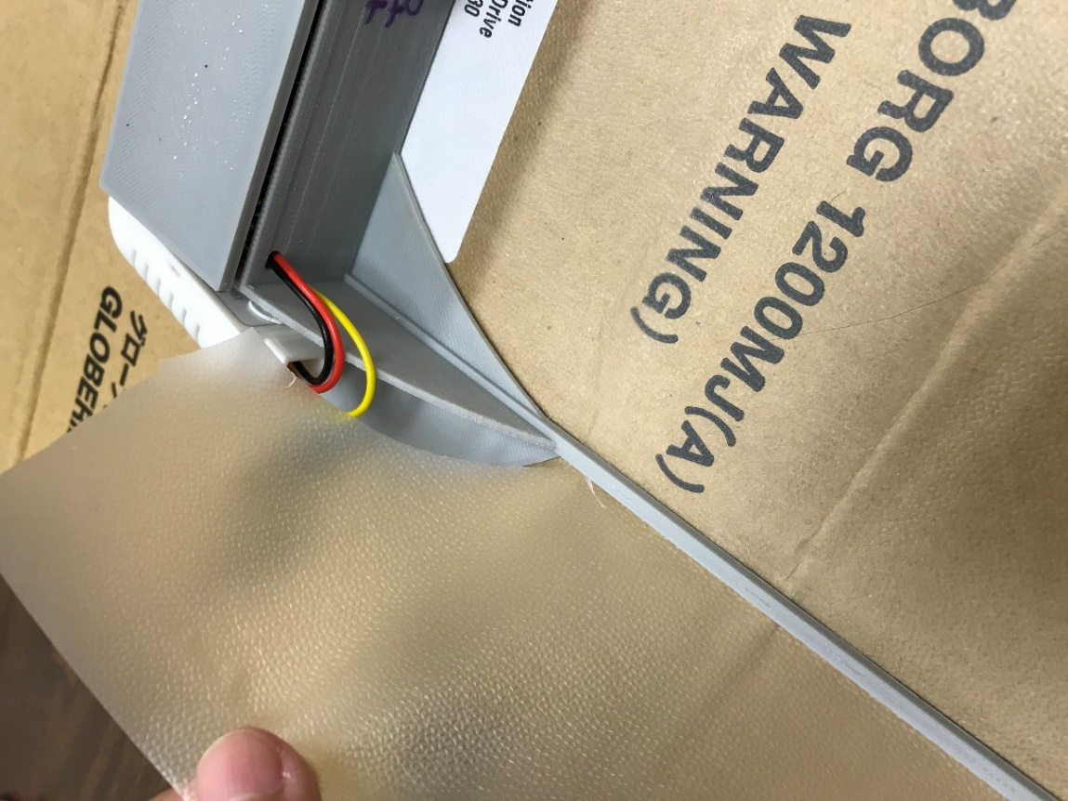

Fold the saran wrap around the wing, and then tape the ends of the saran wrap.

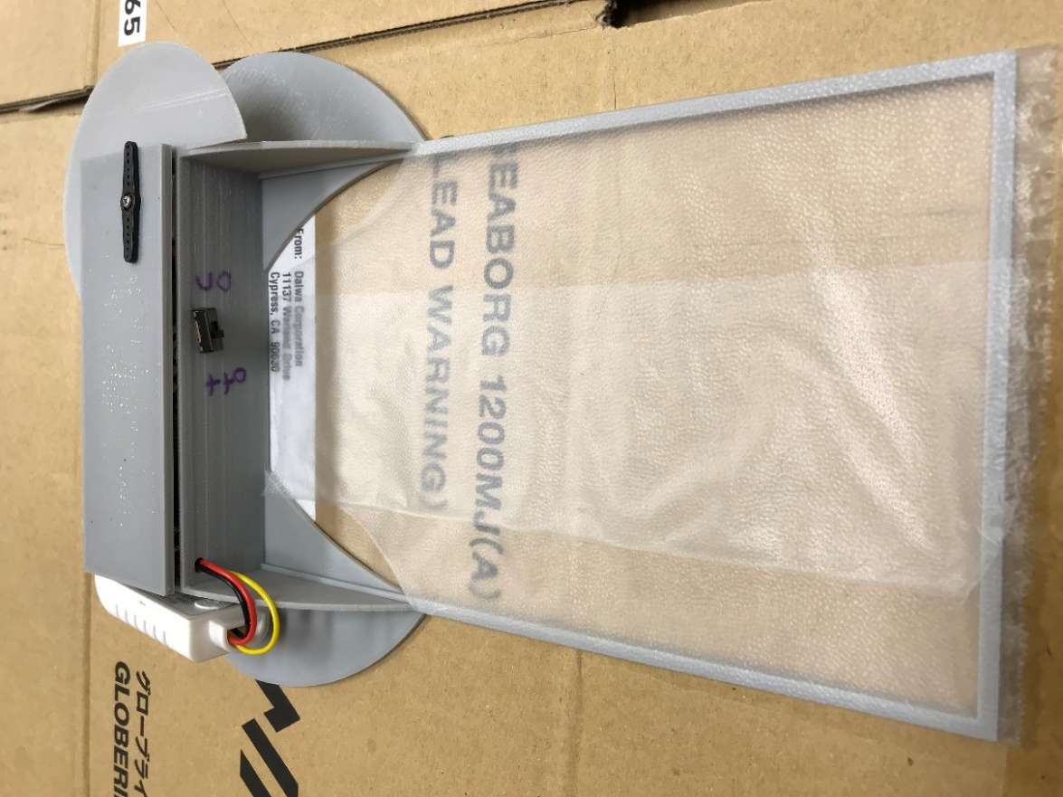

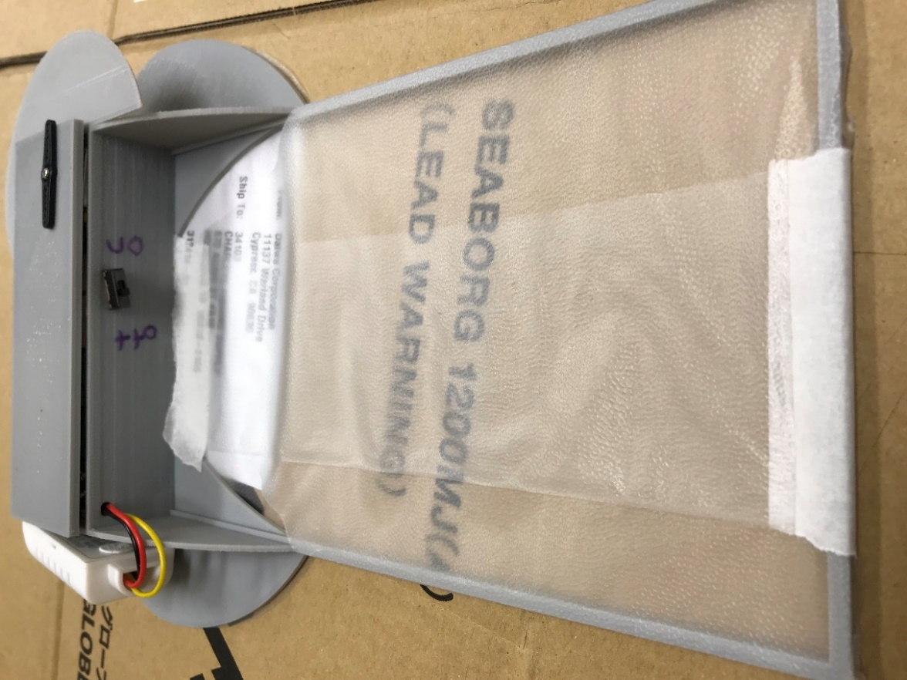

Tape the saran wrap in place on the back of the mini-GNI.

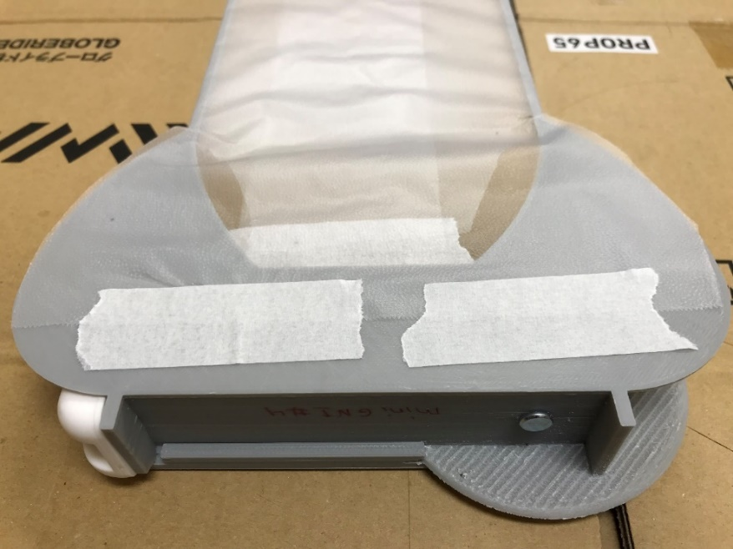

Now we only have one more step. Depending on what instruments and sensors you use in the mini-GNI, the attachment point to the kite string may be different due to a change in mass distribution. The goal is to have the mini-GNI hang straight down from its attachment point. To find the attachment point, you must hold the mini-GNI from the area where the humidity sensor was placed until the mini-GNI hangs approximately vertically. Mark the location – this is where a hole will be drilled.

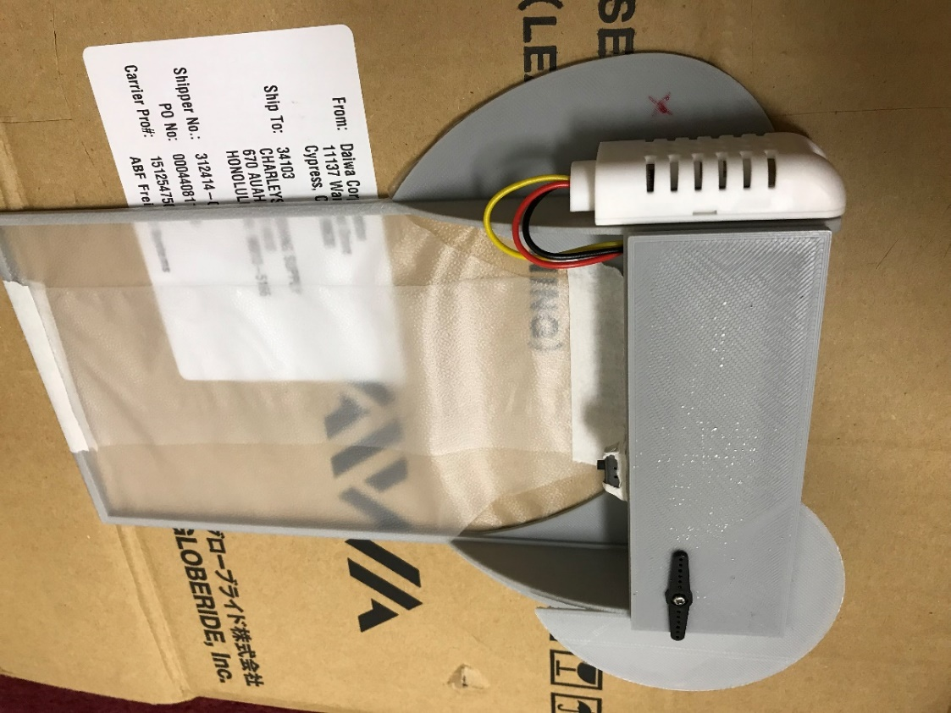

Use a 3/16th-inch drill bit to drill the hole.

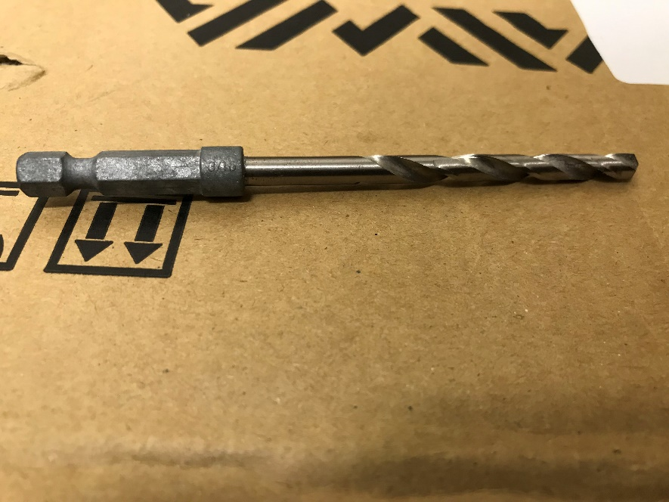

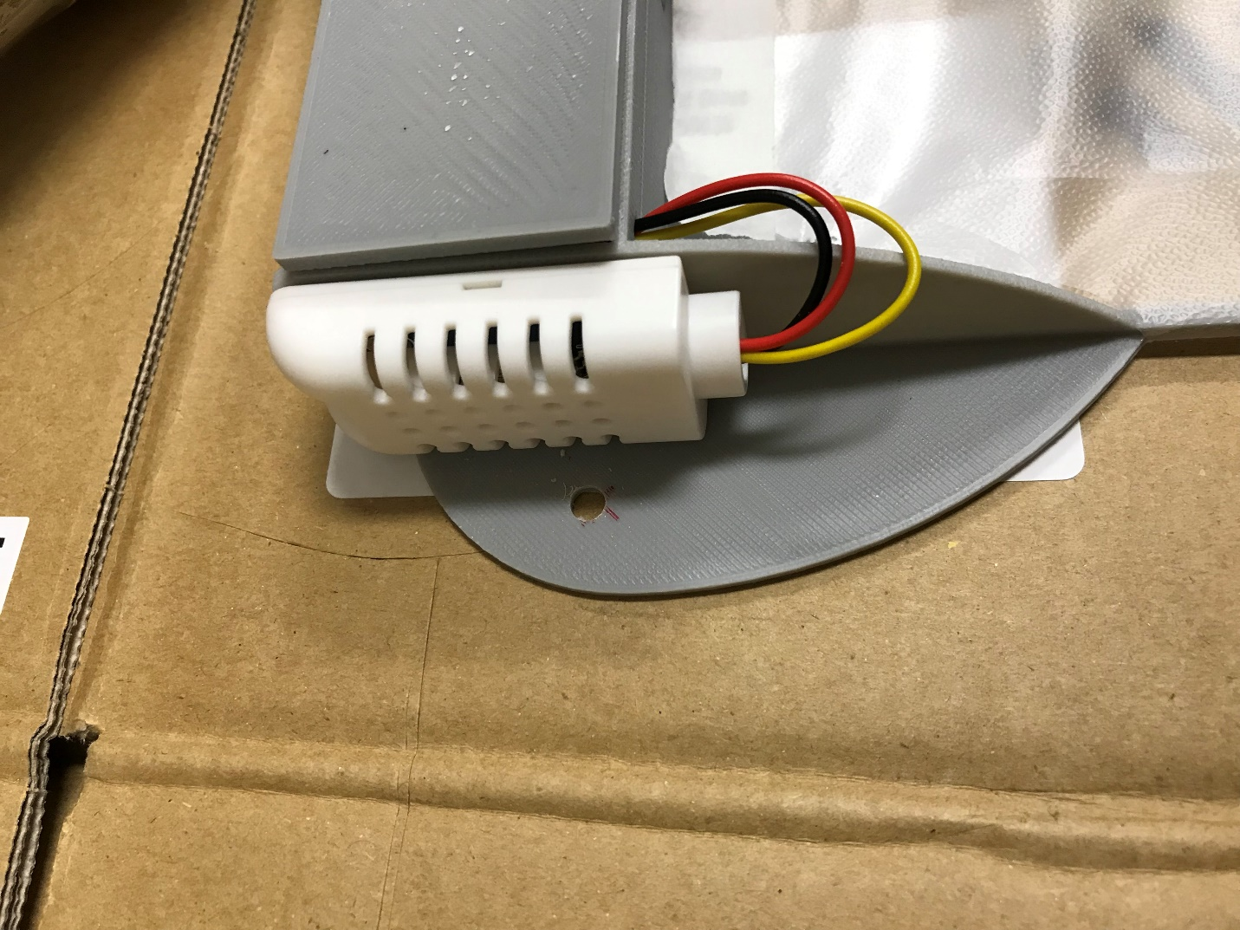

Congratulations! The mini-GNI is complete.

# Control Station Assembly

Now we will construct the control station touchscreen that has radio communication with the miniGNI. First, gather all the necessary parts (Table 2).

|  |  |  |
| --- | --- | --- |
| Part Name | Colloquial Name | Adafruit Part Number |
| Adafruit Feather M0 with RFM95 LoRa Radio (comes with Male Headers) | Feather | 3178 |
| TFT FeatherWing - 2.4” 320x420 Touchscreen | FeatherWing | 3315 |
| Lithium Ion Polymer Battery - 3.7V 350mAh | LiPo Battery | 2750 |
| Table 2: Adafruit parts list for building the mini-GNI control station. | | |

The parts in Table 2 are depicted below along with the 3D casing for the control station.

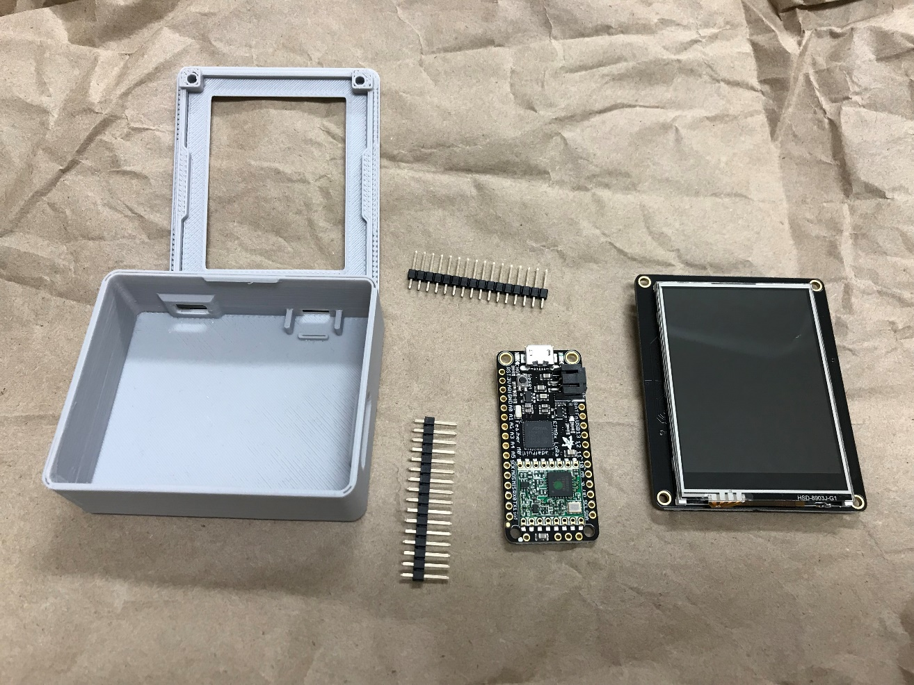

First, cut an 8.3-cm wire for the antenna. Strip only one end.

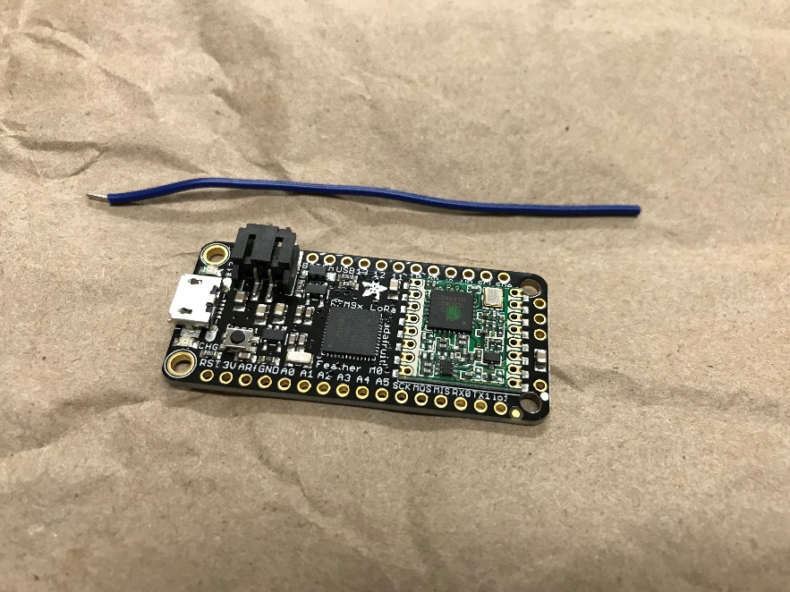

Solder the antenna wire into the hole labeled “Ant” on the Feather. Insert the male headers into the Feather (note that one side requires only 12 rather than 16 pins). Then, attach the Feather with the male headers into the FeatherWing that already has female headers.

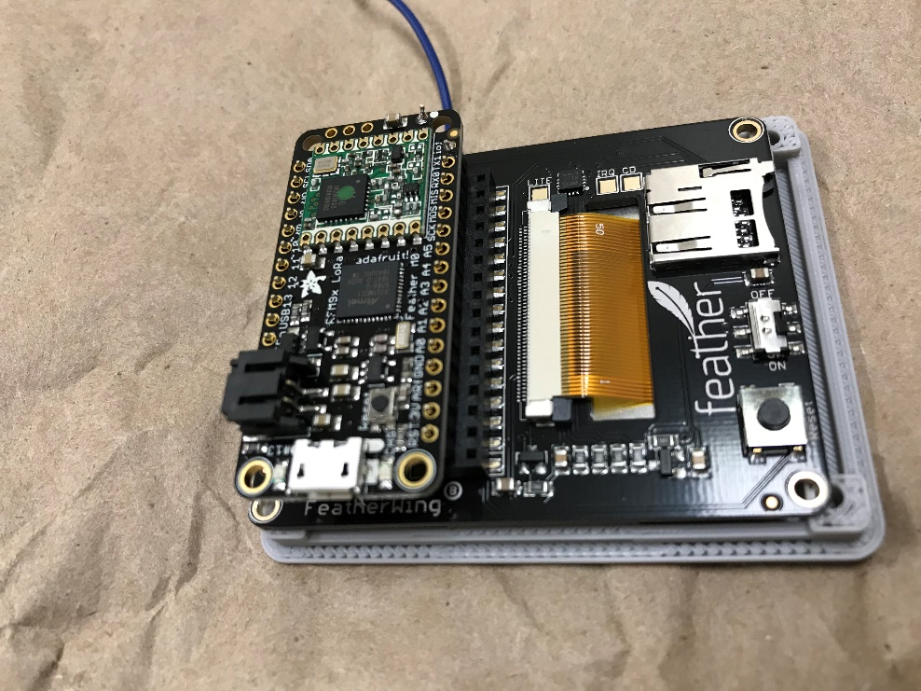

Solder the header pins into place on the Feather.

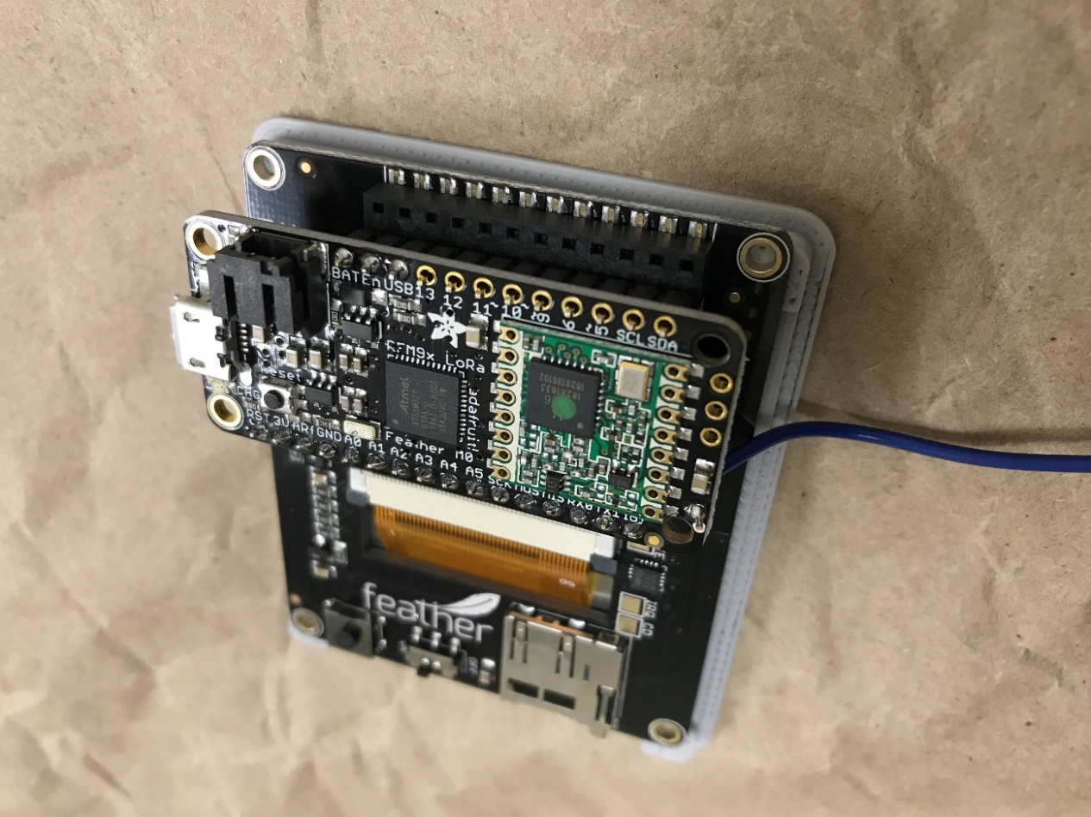

Wrap the antenna wire around something to coil it up.

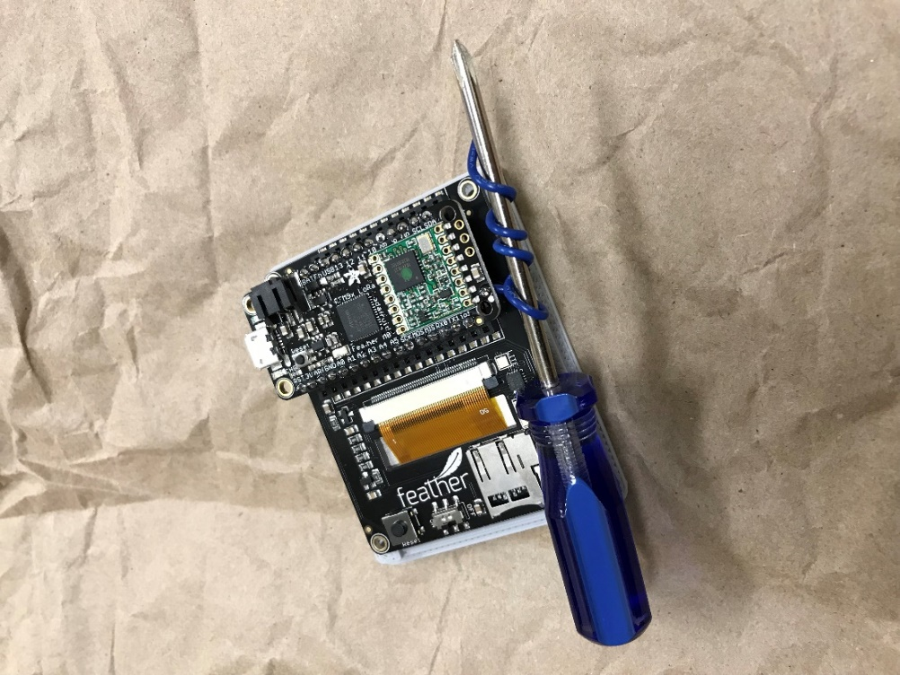

Screw the FeatherWing into the 3D casing and place it into the 3D casing such that the USB port is aligned with a small hole in the casing. Include in the 3D case the LiPo battery.

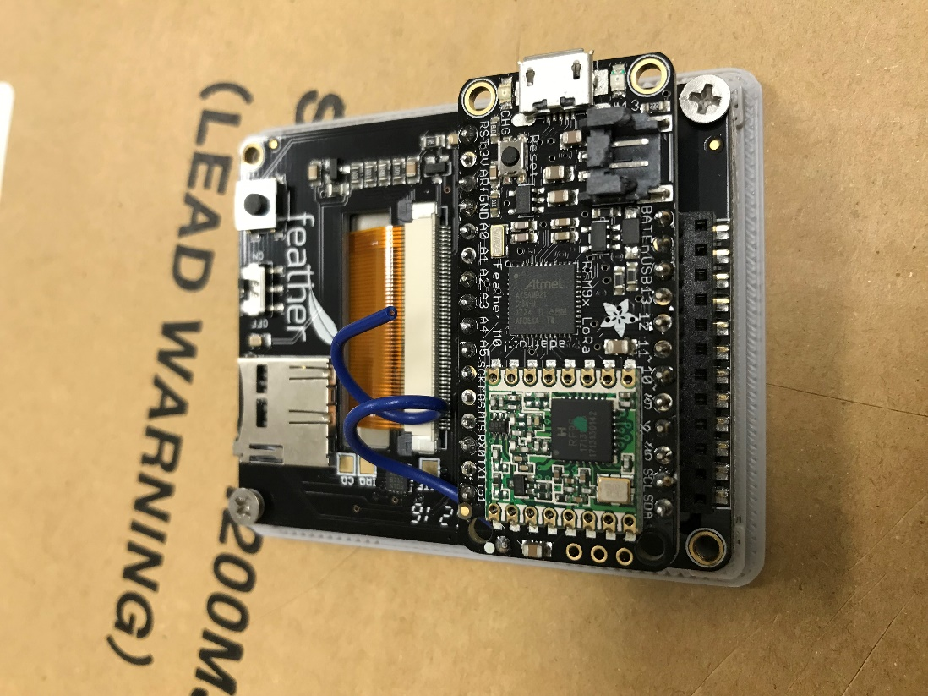

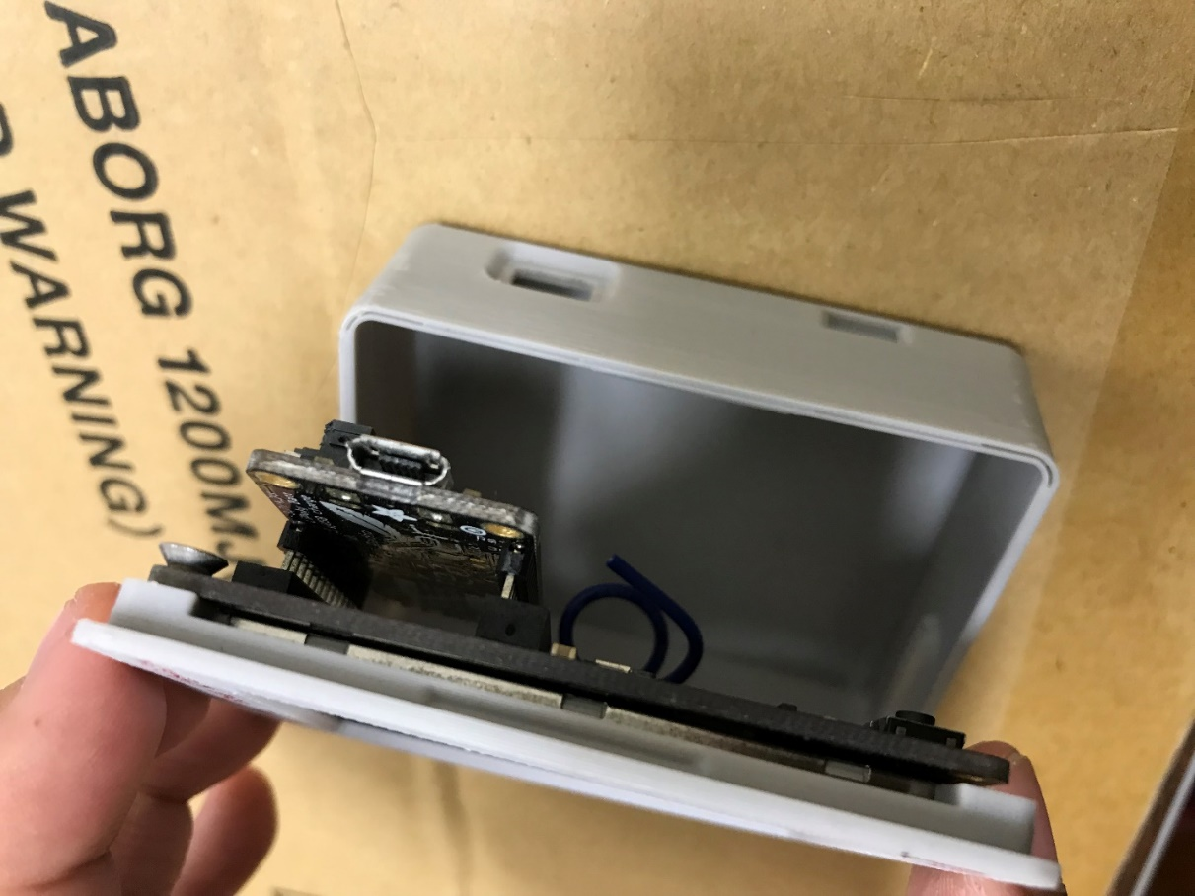

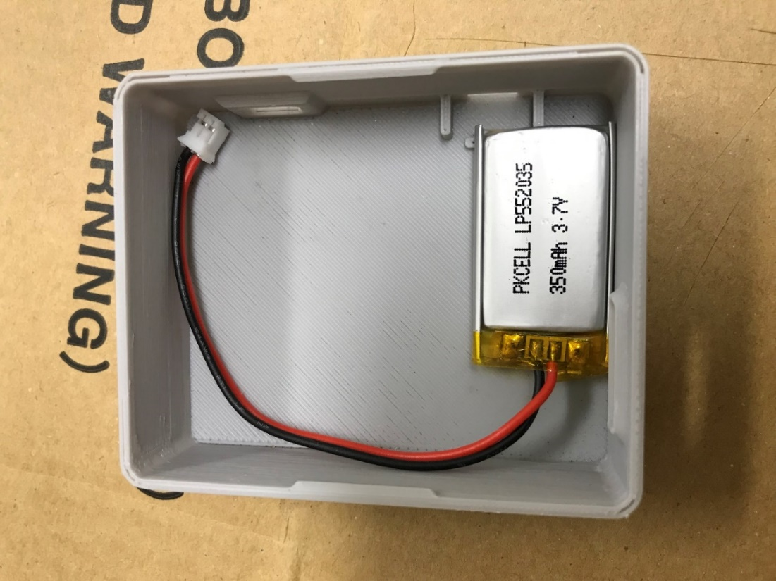

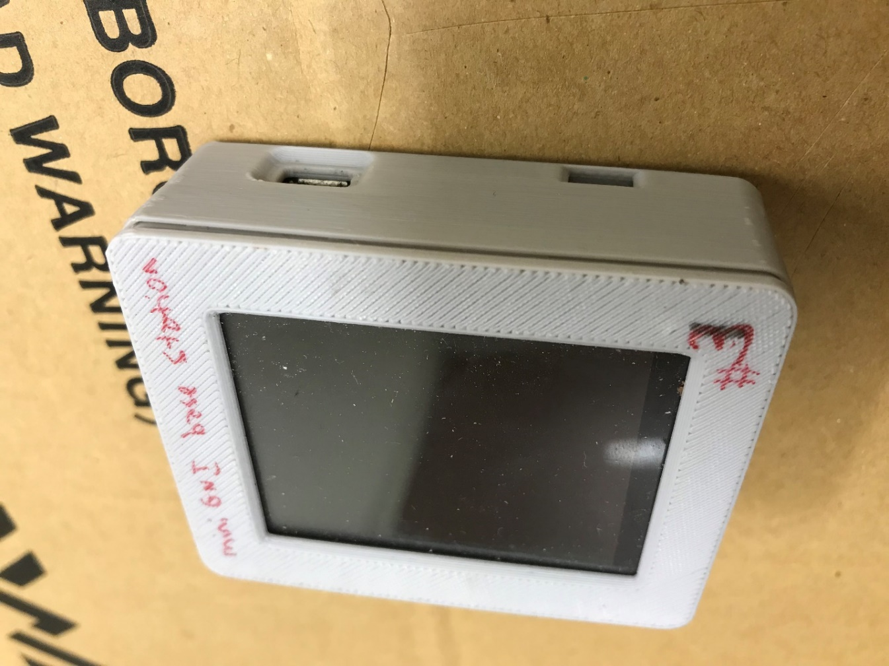

The touchscreen control station is now complete!